

**2019**

**Suryansh Trivedi**

**Utkarsh Gumphekar.**

**Sankalp Patel.**

**Rajat Gour.**

**Raghav Partani.**

**Shivansh Pratap.**

**Umair Qureshi.**

**Ritvik Dubey.**

[Type the company name]

4/30/2019



Xenesis Library Management System

Table of Contents

**Disclaimer………………………………………………………………………….4**

**Acknowledgement…………………………………………………………….……………...………...5**

**Team members………………………………………………………….….…….6**

**Introduction…………………………………………………………….……………...…………………...7**

**Technolegy used………………………………………………………………...8**

**Introduction to QT framework.................................………………………...9**

**System context diagram...................................…………………………….10**

**Use case diagram....................................................................................……………………………….…….11**

**Objective……………………………………………….………………………..13**

**Scope………………………………………………………………………........13**

**Flow of project…………………………………..…………………………….14**

**Project Outputs……………………………………………………….……15-30**

**home:…………..………………….……………………………….15**

**signup……………………………………………………………...16**

**login………………………………………………………………...17**

**subject selection page………………………………………….18**

**book issue system…………………………………………….. 19**

**QR code…………..………………………………………………..20**

**Auto conformarion Mail………………………………………...21**

**admenestrator page……………………………………………..22**

**student database and book database………………………..23**

**add new book and deposit book……………………………..... 24**

**Project database…………………………………………….…….. 25**

**Xenesis web service……..…………………………………….……26**

**website signup page……………………………………………….27**

**Online E-lib card…………………………………………………….28**

**Book record on website…………………………………………...29**

**Student help/Feedback……………………………..................... 30**

**Sample Code……………………………………………………………….…….31-96**

**Conclusion…..…………………………………………….…………………………97**

**Disclaimer**

This Software Requirements Specification document is a guideline. The document details all the high level requirements. The document should be used as a guideline by the students to design the Library Management project. The document also describes the broad scope of the project and high level DB requirements are captured in the DB specification. But while developing the project if the student has a valid point to add more details being within the scope specified then it can be accommodated after consultation.

**Acknowledgement**

We are thankful to our college “ Shri Vaishnav Vidhyapeeth Vishwavidyalaya” and our instructor Mr.“ Gurpreet Singh” for providing us an opportunity to make a software project and giving us all support and guidance which made us complete the project duly, and the knowledge we inherited by our classes with IBM and in making of this project.

I am thankful to and fortunate enough to get constant encouragement, support and guidance from all Teaching staffs of [CS and IT ] which helped us in successfully completing our project work. Also, I would like to extend our sincere esteems to all staff in laboratory for their timely support.

And last but not the least we would like to thank our Parents, class mates, and to all who contributed to this project.

Sincerely,

**Team Xenesis**

**Team Members**

* **Xenesis Team Leader :**

Suryansh Trivedi

* **Xenesis Team Members :-**

1. Utkarsh Gumphekar.
2. Sankalp Patel.
3. Rajat Gour.
4. Raghav Partani.
5. Shivansh Pratap.
6. Umair Qureshi.
7. Ritvik Dubey**.**

**Team Xenesis:**

**Xenesis.lib@gmail.com**

**Introduction**

* SVVV, Indore is a renowned university of Indore . SVVV is trying to expand their Library and would like to provide an automated library management system. One of the most important part of an institution is library management . Students are provided with the facility of making their E-lib Id ,And the administrator will also be provided the ease of managing the student data available and edit it , Administrator will also be able to manage all the data of books.
* In our software Xenesis there will be a separate database for books issue and the penalty of late submission etc. Currently, the student have to visit the Library physically to issue a book . While doing so a great time is wasted in finding books in racks , check the avaibility of books etc. of time in application, Xenesis:Library charges payment, complaint registration -etc. Some of the customers have also questioned the transparency of Xenesis:Library allocation. To maintain the trust and reduce the Xenesis:Library Service cycle time, the library has decided to add the service of Xenesis:Library application, Complaint registration and Xenesis:Library charges payment on their web portal.
* The Library Management System should be used by the students and librarians to manage the library by software automation.

**Technologies used**

* **QT framework.**
* **SQL (php my Admin)**
* **Apache server**
* **SMTP server – auto mail**
* **QR scanner**
* **HTML,CSS,PHP**
* **Autorun(windows batch programming)**
* **Further technologies:-**
* **Hashing algorithms and Salting for password sequence.**

**Introduction to QT framework**

* Pronounce as “cute” or QT.
* QT is an open source software.
* Cross platform application development framework.
* User experience across hardware platforms.
* It goes beyond GUI (database access, xml parser, web,….)
* It can bind to any language and can be written in C++, python, C#, Ruby, Ada, Pascal, PHP,Perl, and Java.
* It is high quality, mature, free, excellent support for localisation, support 32/64 bit computing.
* It contains rich set of widgets(1000+) , Qwt(25+) classes.
* Very good documentation, help, and examples.

**System context diagram**

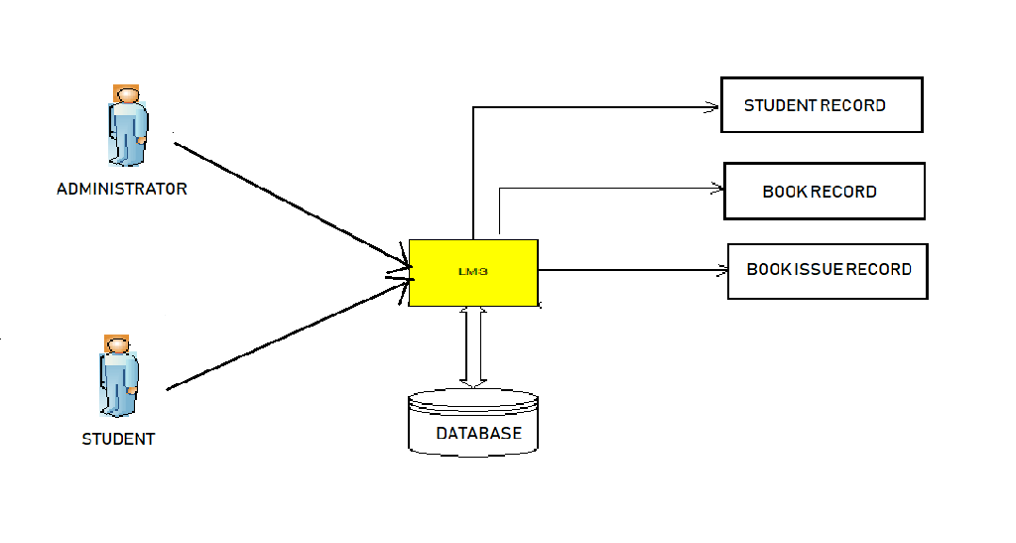

* The diagram above explains the main conceptual elements in the solution and their relationships with our library management software. The Xenesis: Library Management System ( XLMS ) will have the data of the students who have made their accounts on our software and also can make new account. Library management system will have to manage the request from students and administrator also at the same time. Authorized Administrators/Librarians will maintain Library details through the system which in turn will be accessed by the students through their E-lib cards. The interface with the existing Student Account and data of books, books issuing Management will be fully shared with the administrator for Xenesis: Library management and Management related to the penalties.

**Use case diagram**

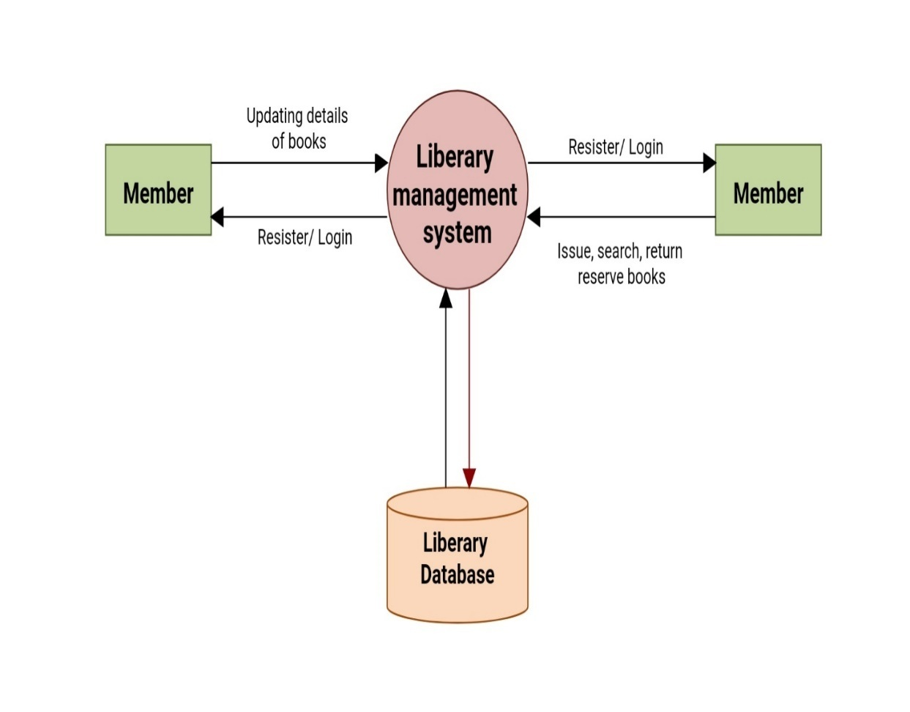

* The high level functional requirement for the Xenesis: Library Management System ( XLMS ) for SVVV is represented in the Use Case diagram shown above.
* Following are the identified functional requirements of the XLMS System
* Provide role based access to the system (Student and Administrator)
  + Librarian / Administrator – To Login and maintain Xenesis: Library details. To approve Xenesis: Library requests, discontinuation requests, get various analytical reports and add new contents in software and in physical.
  + Registered Student – To Login and get knowledge about all books status in library and manage E-lib card for book issuing.

The diagram above explains the main conceptual elements in the Library Management System. The Xenesis Library Management System ( XLMS ) component interacts with the Students, books management system and Administrator. These systems receives requests from librarian and students . Librarian will maintain library details through the administrator which in turn will be accessed by the students

**Objective**

The purpose of the project is to maintain the details of books and library members of different branches. The main purpose of this project is to maintain a easy circulation system between students and the libraries, to issue books using single library card, also to develop a software to which helps issuing and deposit a book through student login and update the book database from administrator login with some administrator feature comes with our Xenesis library management system(XLMS) and to maintain details about the user (fine, address, phone number).Moreover, the user can check all these features from their home.

**Scope**

* This document describes the scope of the requirements for the ( LMS ) for SVVV. The document details all the high level requirements with intent to validate SVVV requirements. This document should be used by the student to design the Library Management project. In addition to this, the document also describes the broad scope of the project. The scope of the project involves the integration of a subset of all the components of current IT environment. The ( LMS ) should interface with the Librarians and students.
* The system must maintain central data for effective library management, Student login, student signup, administrator login, administrator signup. The system should process the online student’s request for book issuing,
* Xenesis: Library will also contain the book availability data, book returning date. The database will also contain the reference book of each subjects. The administrator privileges will contain the access to all the student’s data and would be able to manage all the student record like payments, renewing E-lib card and also generate various reports about the books. There is also the need to have an interface for students where they can view all the details about their E-lib id and also see the book availability anywhere. The system must maintain all details about Library allocation transaction of penalty of the student. The scope of the project also involves the development of the interfaces with the existing one which is totally manual working type to the semi/automated library management system, which will contain all the student record about their book issuing, availability of books, E-lib card which can be used for one book issuing detail, book returning details. Account system that validates the student and librarians/administrator helps in easy communication between operator the system and thus ease of management in Library.

**Flow chart of our program**

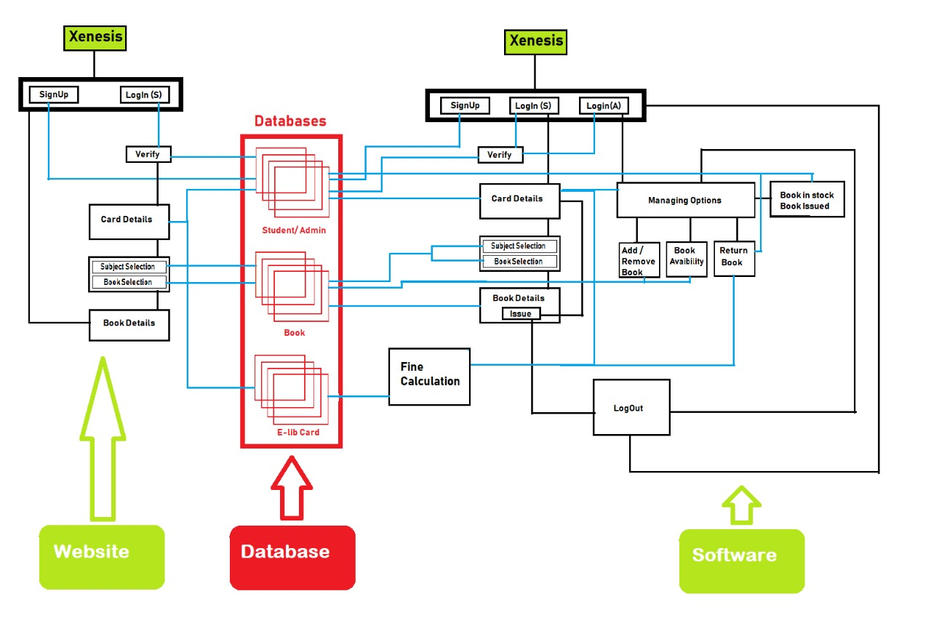

**Home page**

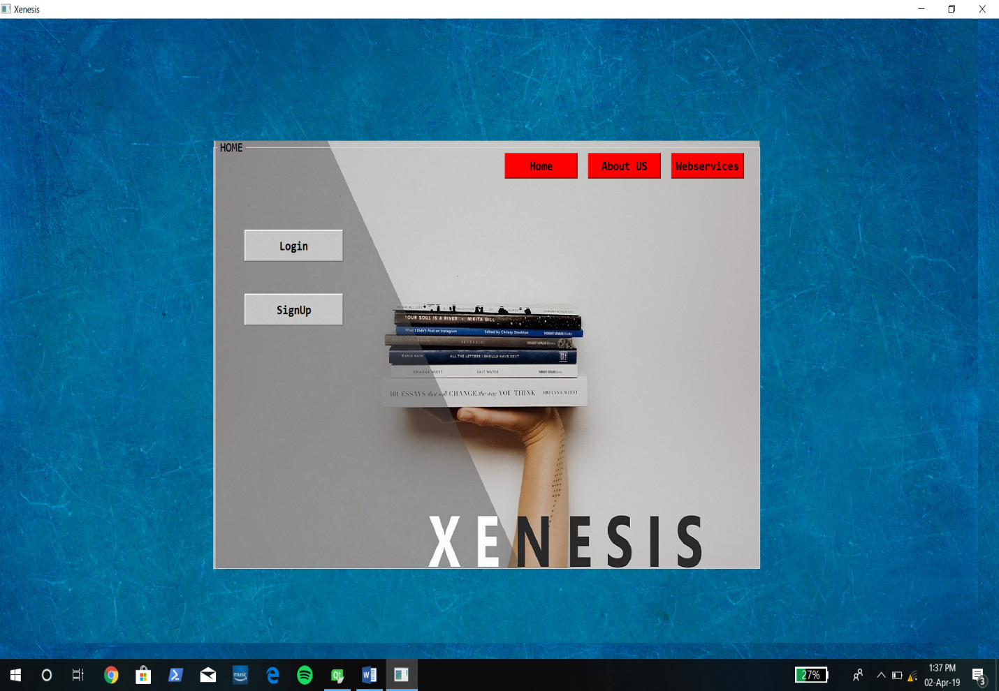

* **This is the home page of our project.**
* **By clicking on signup button the user can make his/her account.**
* **The members can do a direct login.**

**Signup page**

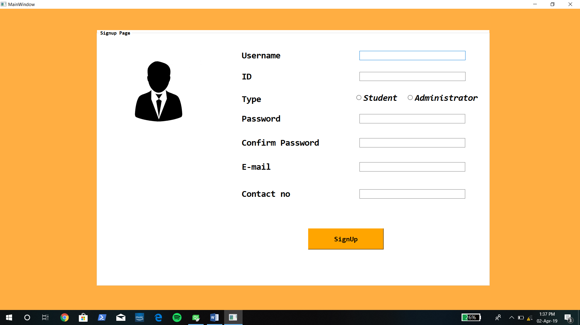

* **This is the signup page where new members can enter their details**

**and become a member of XLMS.**

* **The details will be saved to our database and can be accessed by**

**the Administrator.**

**Login page**

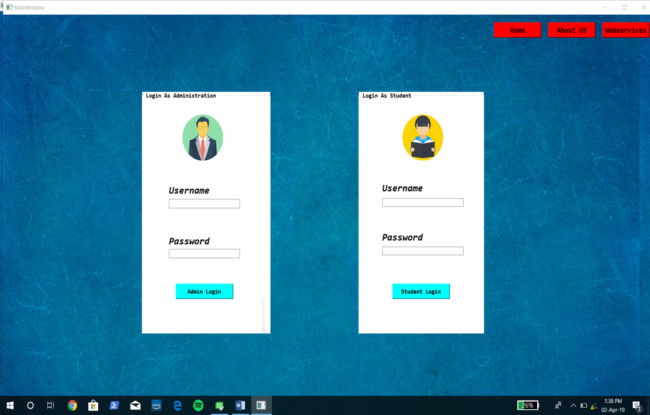

* **This is the login page where registered user can access their privileges.**
* **There are 2 fields to login**
* **Admin login**
* **Student login**
* **By logging in the user can enjoy their privileges.**

**Subject selection page**

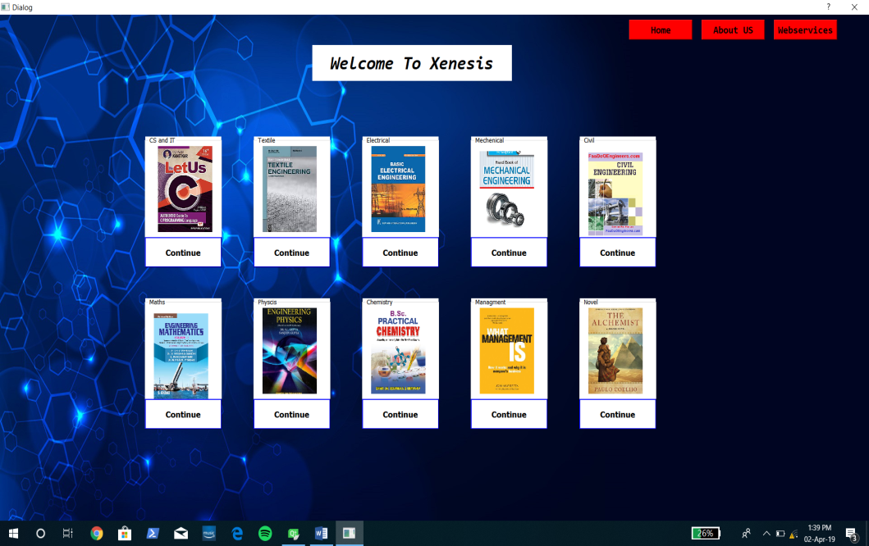

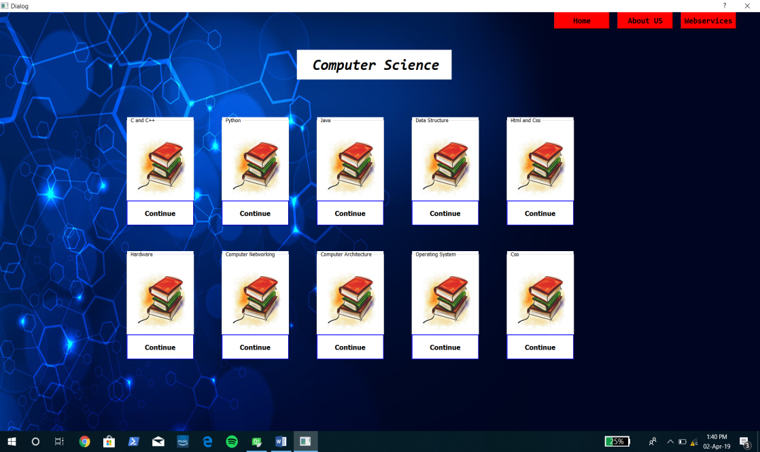

**Book issuing system**

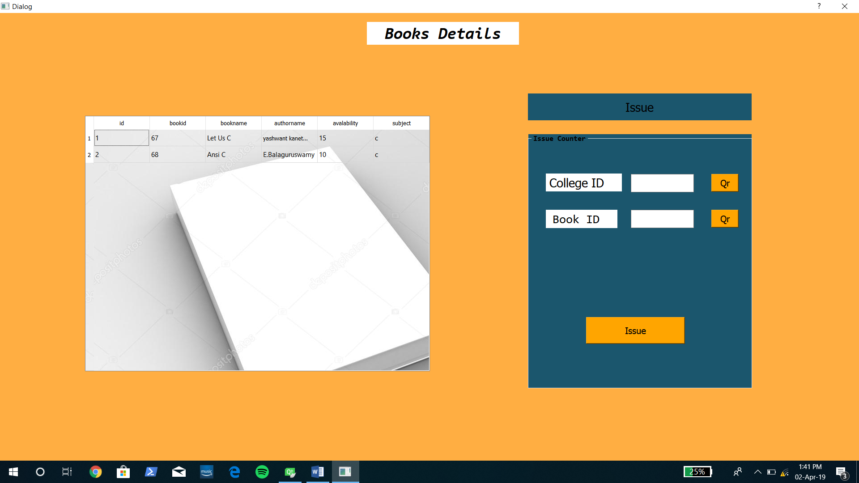

* **This is our book issuing and book availability page.**

**Qr code**

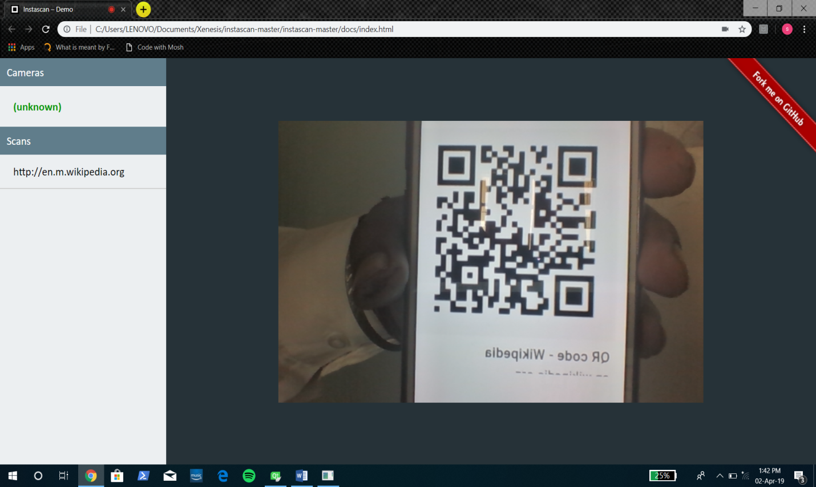

* **This is the QR code scanner which will be used to scan Book Id and thus will provide fast working.**
* **The scanned data will be saved in the database.**

**AUTOCONFIRMATION MAIL**

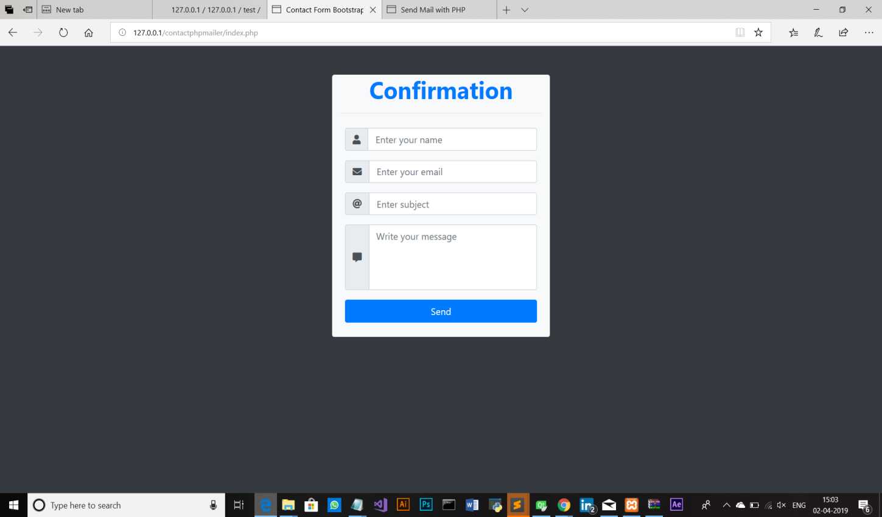

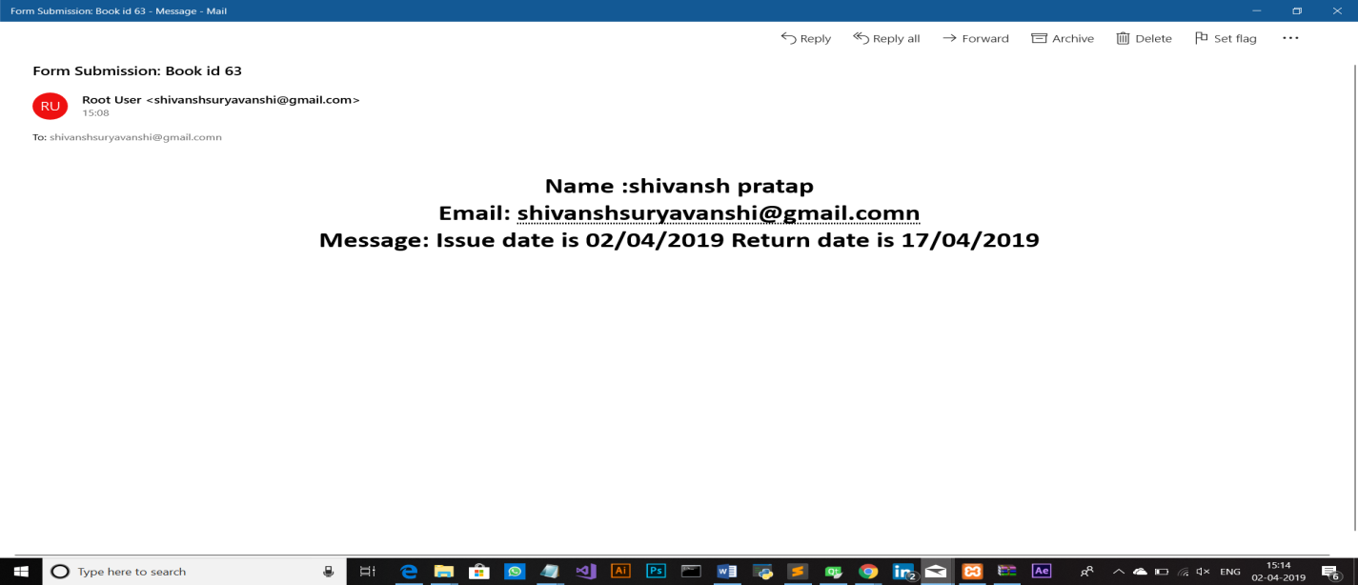

**Administrator page**

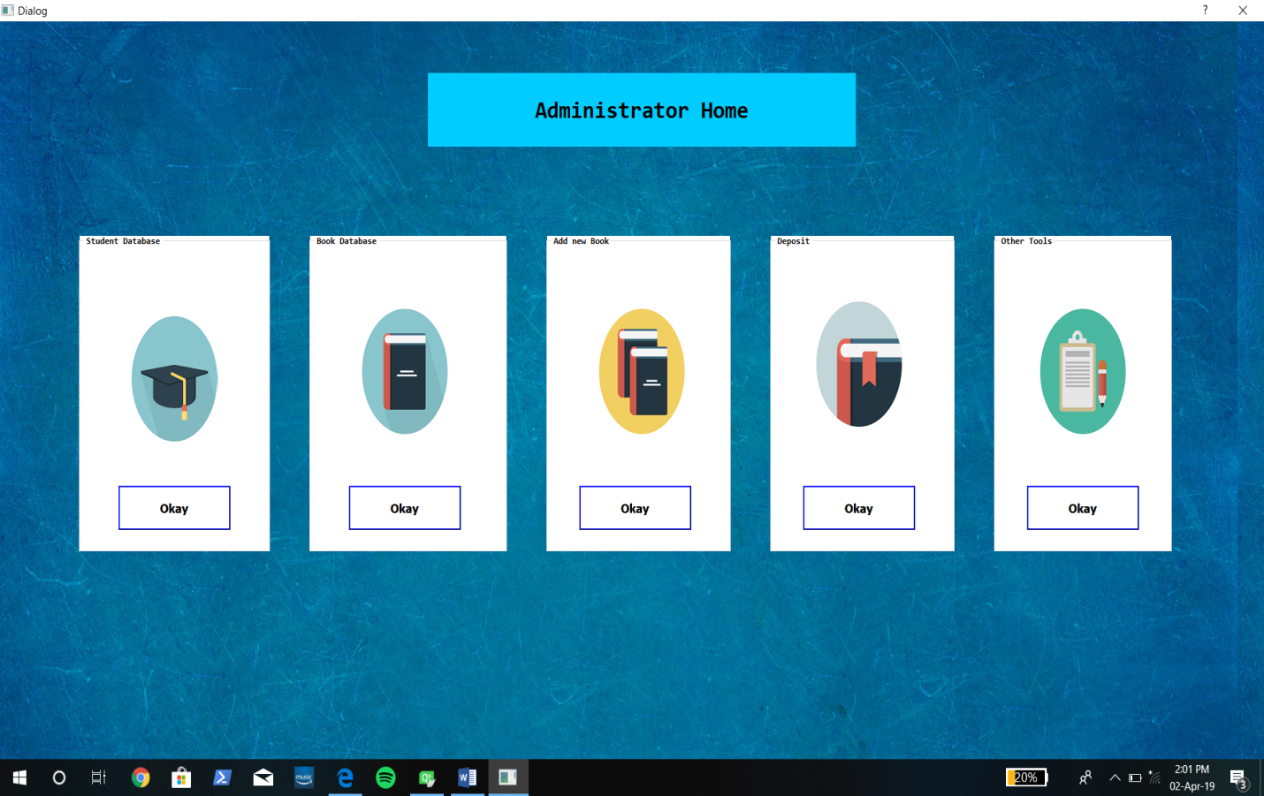

* **This is the administrator page where the software has been given various**

**privileges.**

* **Where he can view , edit, student record.**
* **The book record also can b edited .**

**Student’s database and book database**

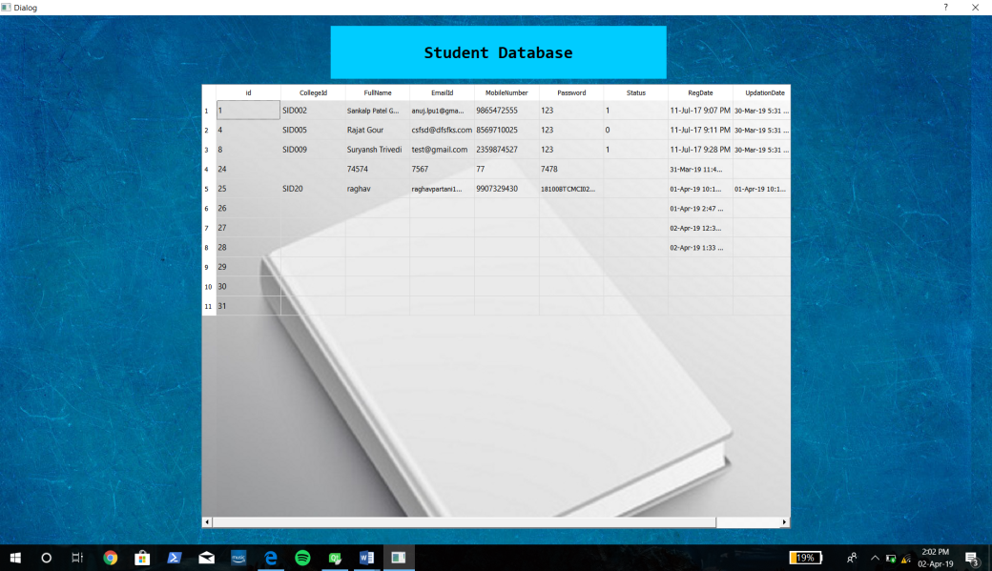

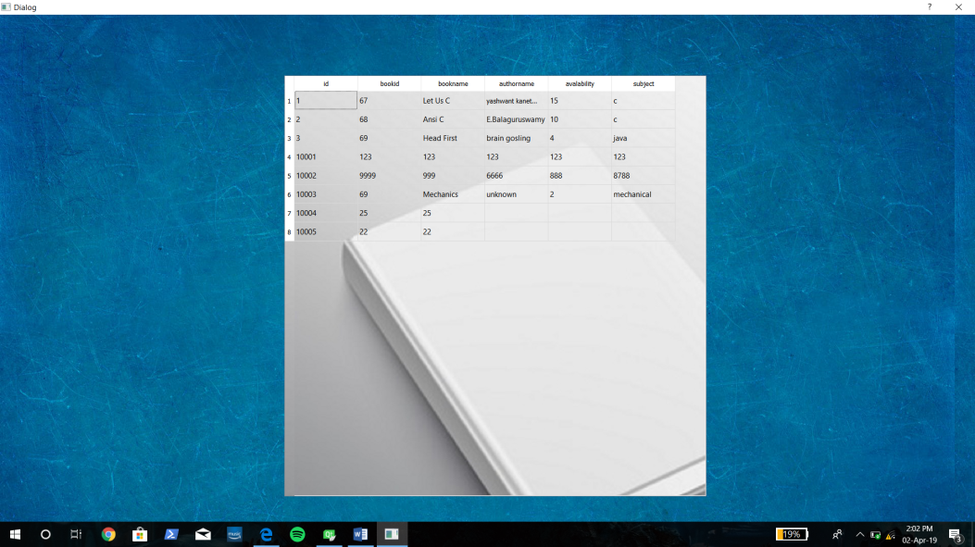

* **This is the tables which will be displayed on our system which will be directly fetch from the database.**

**Add book and deposit book**

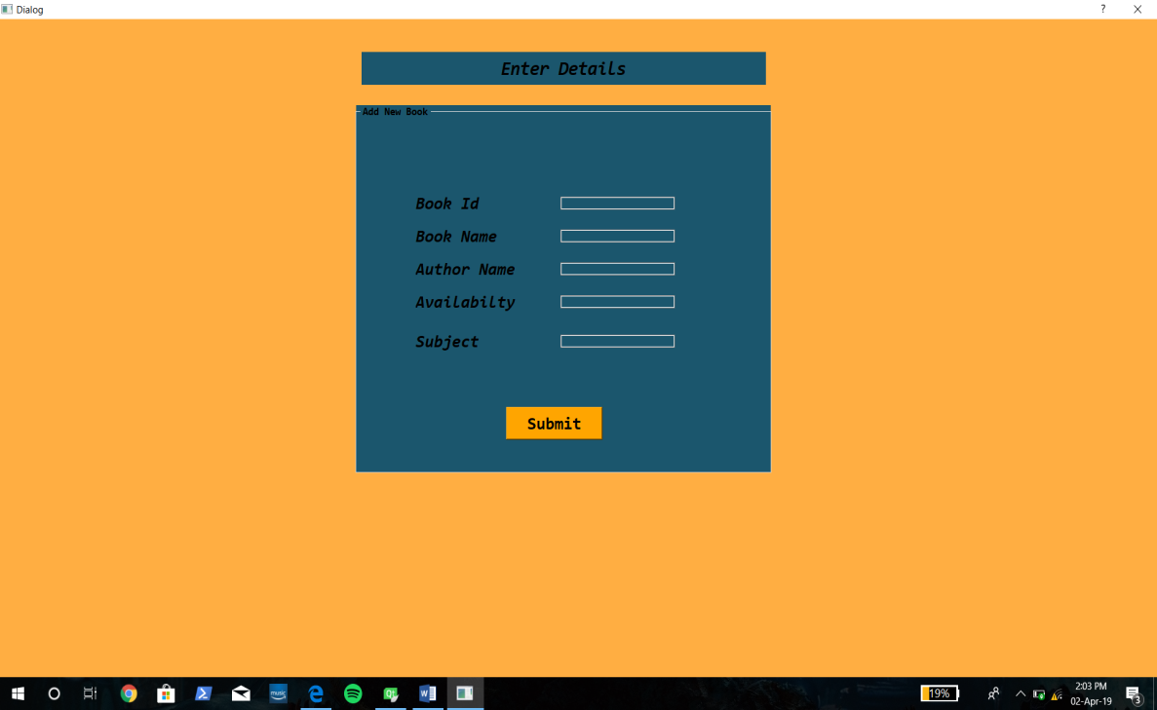

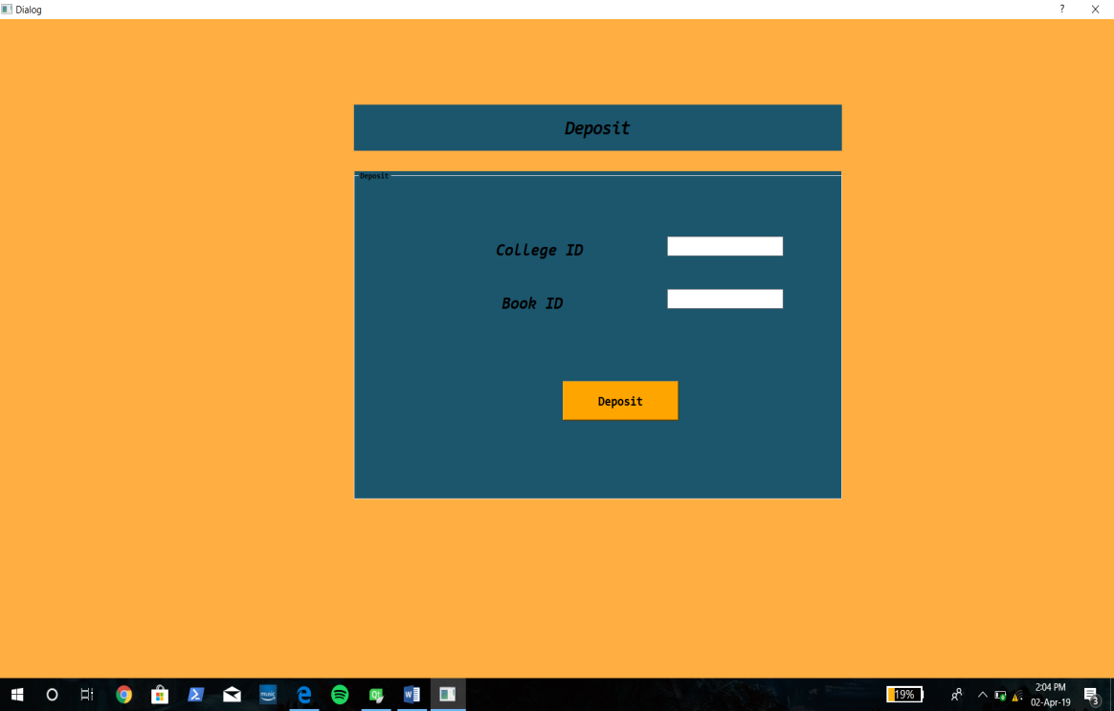

* **This is our book search and book deposit page.**

**Project database**

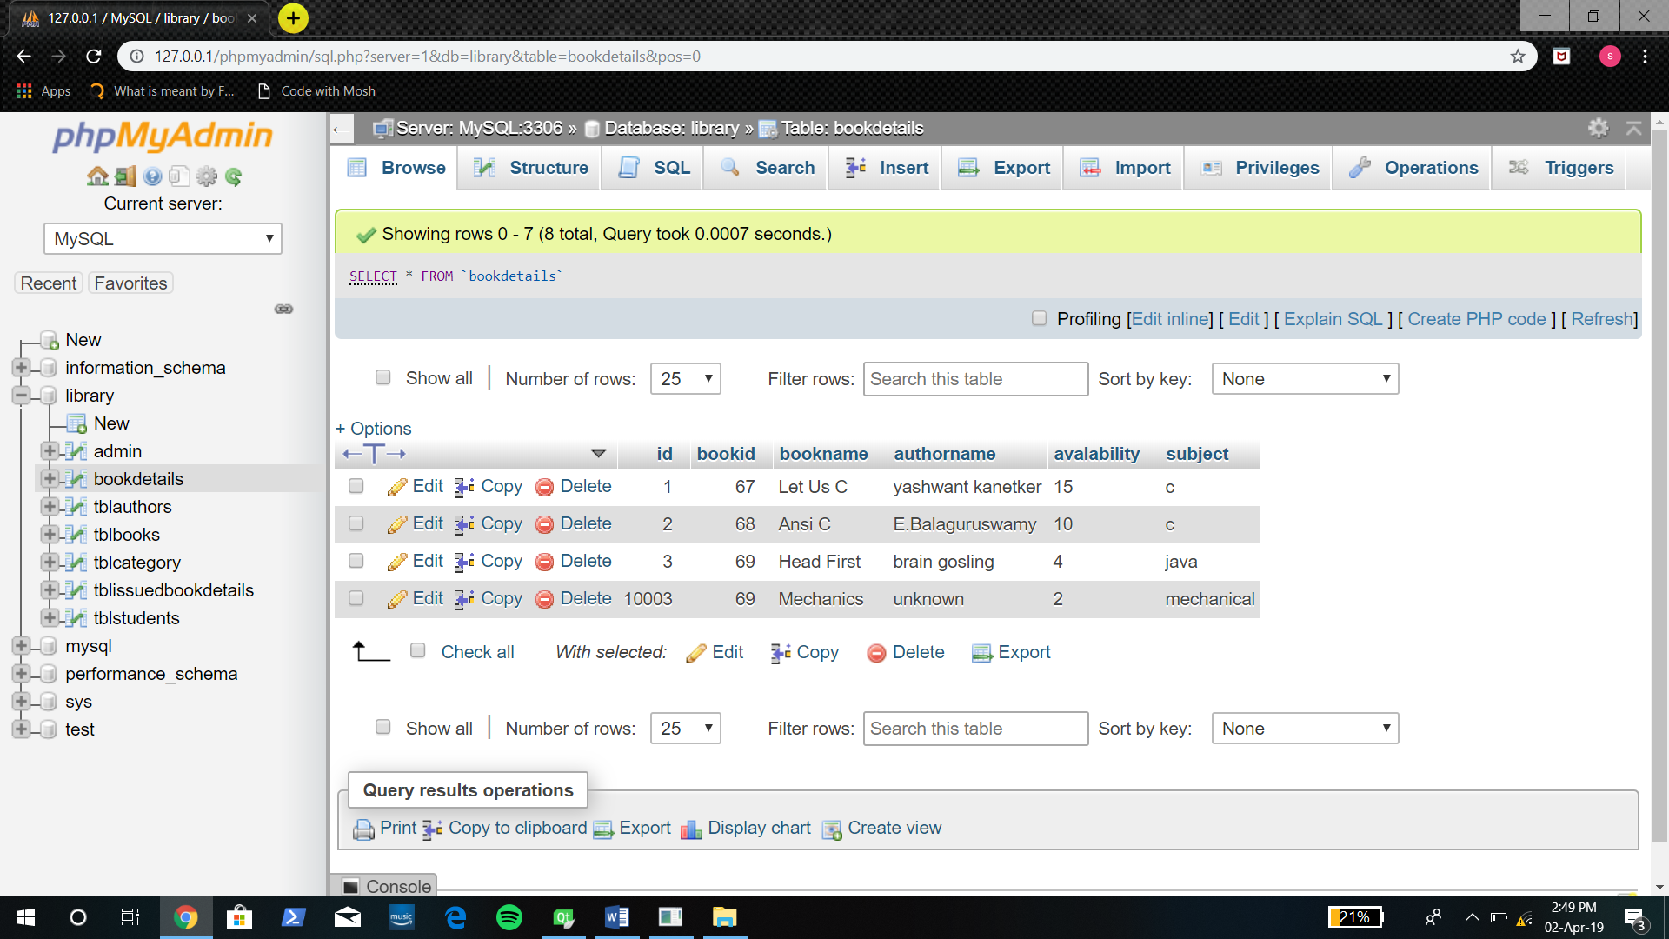

* **The project’s database is On My sql and on php my admin.**
* **The database has been setup on WAMP server.**

**Xenesis web services**

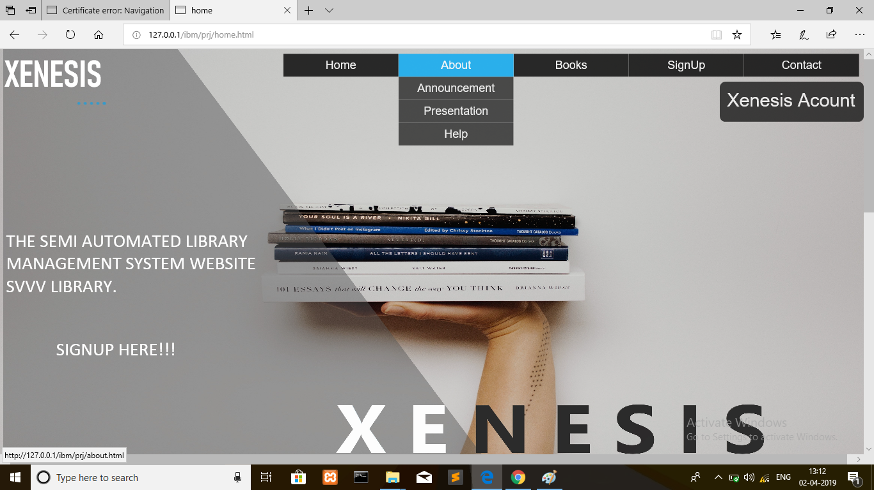

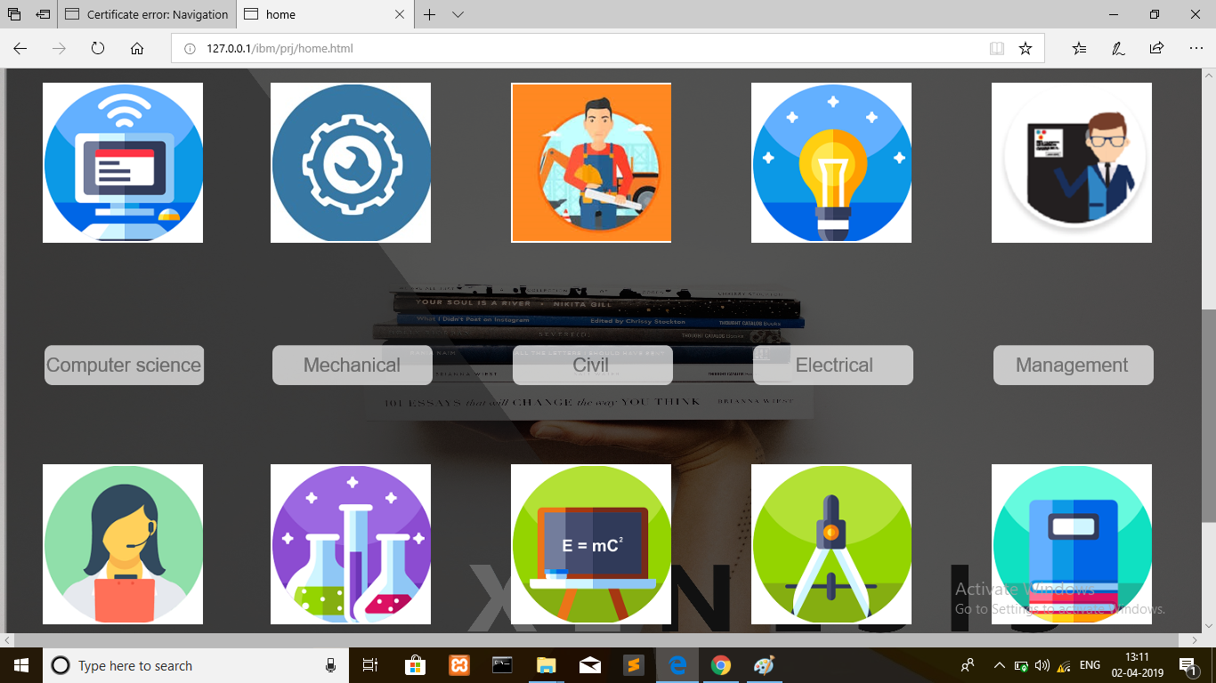

**This our Xenesis library website in which student can access the library details online from any Where.**

**Website signup page**

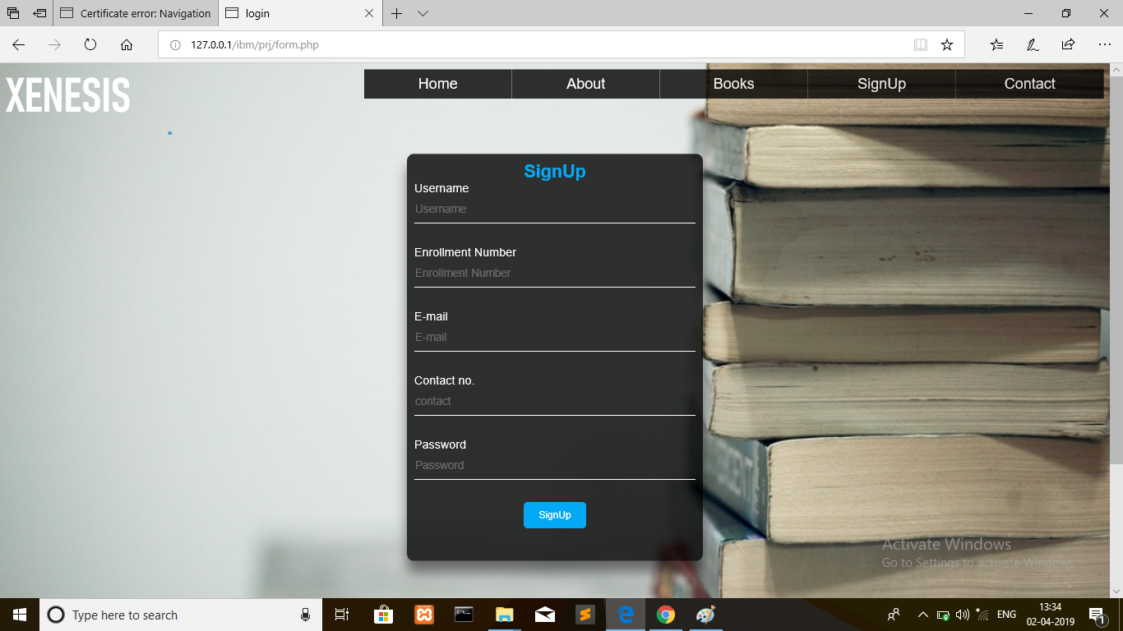

**Online e-lib card detail**

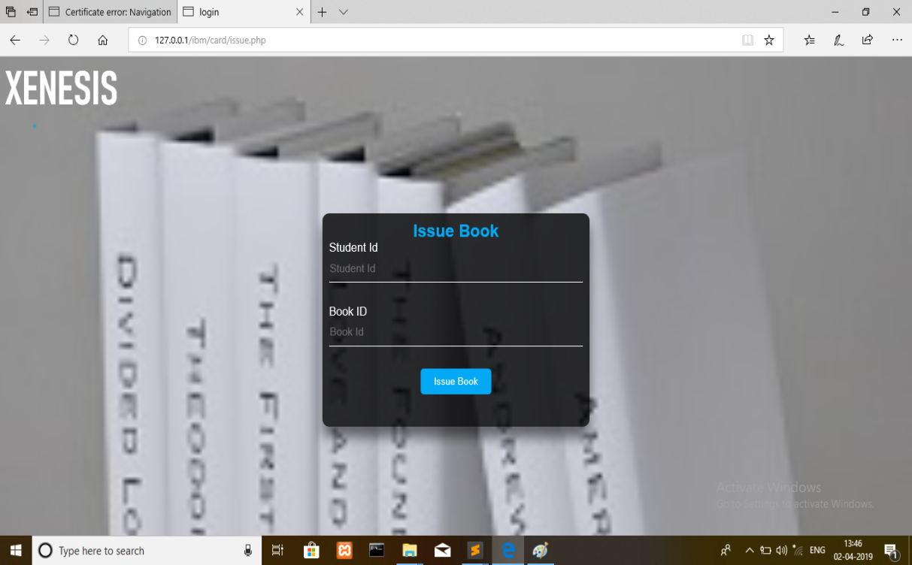

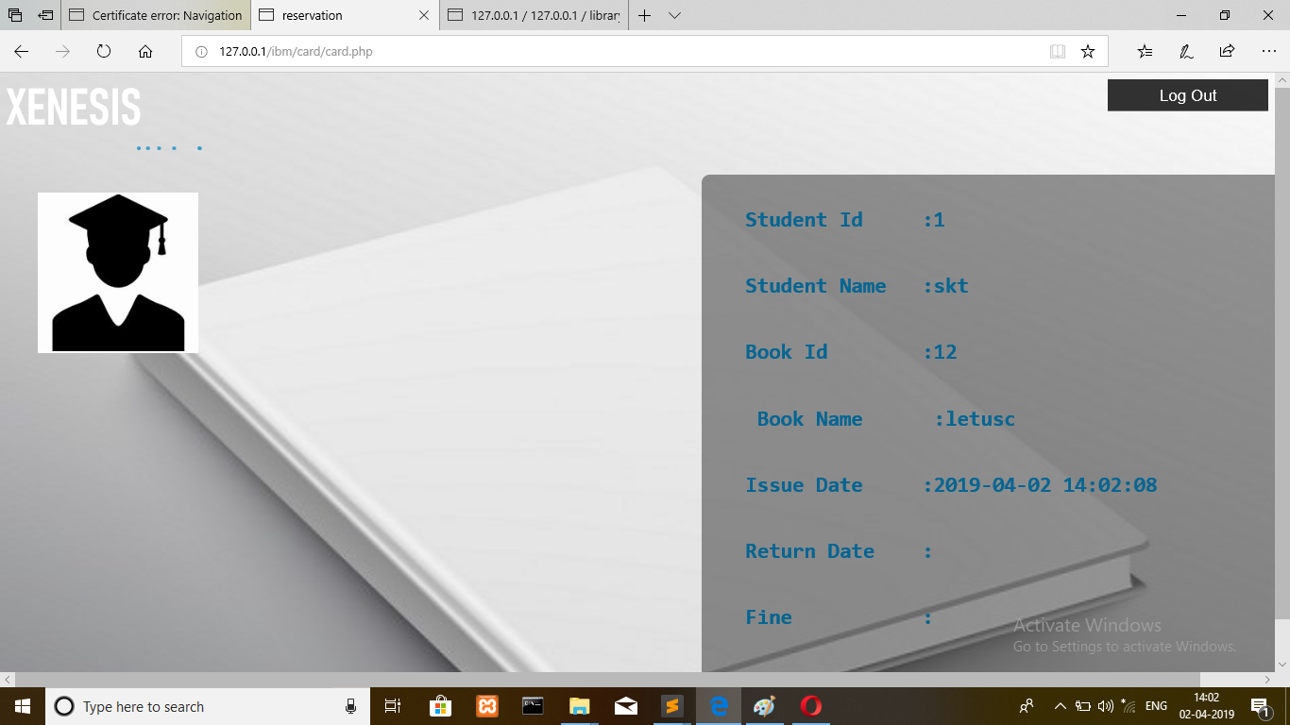

**Book record on website**

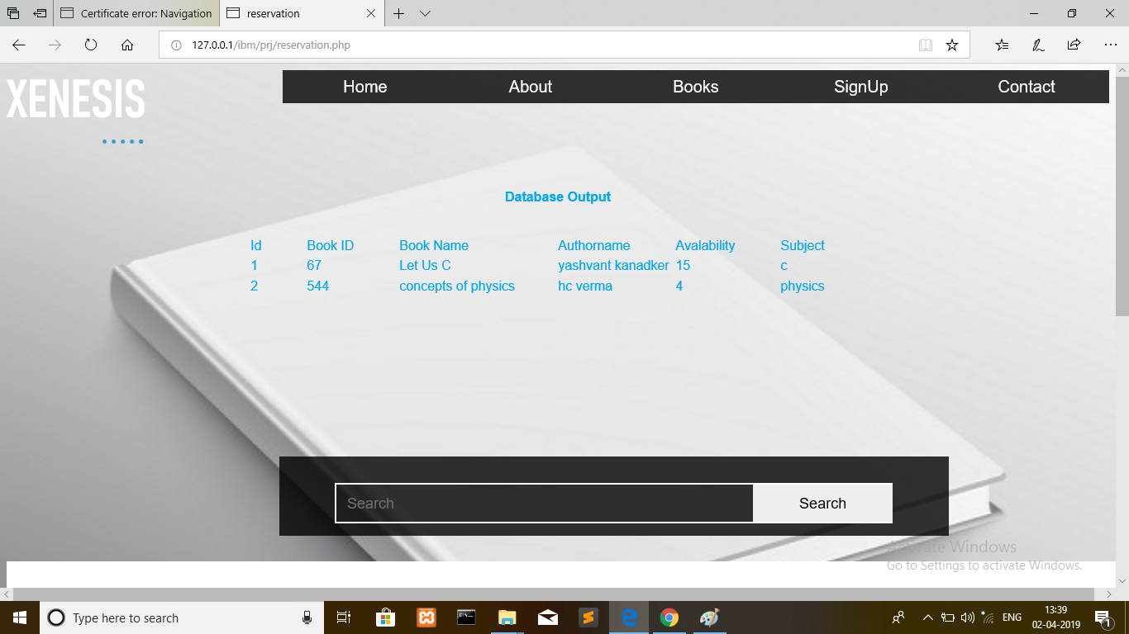

**Student help / feedback**

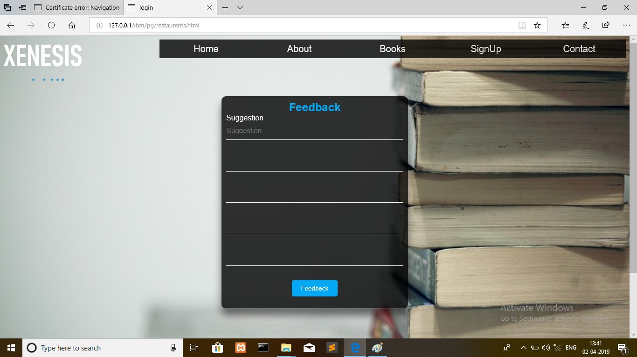

**SAMPLE**

**CODE**

**Xenesis.pro**

**#-------------------------------------------------**

**#**

**# Project created by QtCreator 2019-03-26T14:05:54**

**#**

**#-------------------------------------------------**

**QT += core gui sql**

**greaterThan(QT_MAJOR_VERSION, 4): QT += widgets**

**TARGET = Xenesis**

**TEMPLATE = app**

**# The following define makes your compiler emit warnings if you use**

**# any feature of Qt which has been marked as deprecated (the exact warnings**

**# depend on your compiler). Please consult the documentation of the**

**# deprecated API in order to know how to port your code away from it.**

**DEFINES += QT_DEPRECATED_WARNINGS**

**# You can also make your code fail to compile if you use deprecated APIs.**

**# In order to do so, uncomment the following line.**

**# You can also select to disable deprecated APIs only up to a certain version of Qt.**

**#DEFINES += QT_DISABLE_DEPRECATED_BEFORE=0x060000 # disables all the APIs deprecated before Qt 6.0.0**

**CONFIG += c++11**

**SOURCES += \**

**main.cpp \**

**mainwindow.cpp \**

**dialog1.cpp \**

**home.cpp \**

**first.cpp \**

**singup.cpp \**

**cs.cpp \**

**cs_c_language.cpp \**

**ad_home.cpp \**

**ad_student.cpp \**

**ad_books.cpp \**

**ad_deposit.cpp \**

**ad_students_2.cpp \**

**ad_addnewbooks.cpp \**

**xte.cpp \**

**xel.cpp \**

**xme.cpp \**

**xcv.cpp \**

**xma.cpp \**

**xpy.cpp \**

**xch.cpp \**

**xmba.cpp \**

**xnv.cpp**

**HEADERS += \**

**mainwindow.h \**

**dialog1.h \**

**home.h \**

**first.h \**

**singup.h \**

**cs.h \**

**cs_c_language.h \**

**ad_home.h \**

**ad_student.h \**

**ad_books.h \**

**ad_deposit.h \**

**ad_students_2.h \**

**ad_addnewbooks.h \**

**xte.h \**

**xel.h \**

**xme.h \**

**xcv.h \**

**xma.h \**

**xpy.h \**

**xch.h \**

**xmba.h \**

**xnv.h**

**FORMS += \**

**mainwindow.ui \**

**dialog1.ui \**

**home.ui \**

**first.ui \**

**singup.ui \**

**cs.ui \**

**cs_c_language.ui \**

**ad_home.ui \**

**ad_student.ui \**

**ad_books.ui \**

**ad_deposit.ui \**

**ad_students_2.ui \**

**ad_addnewbooks.ui \**

**xte.ui \**

**xel.ui \**

**xme.ui \**

**xcv.ui \**

**xma.ui \**

**xpy.ui \**

**xch.ui \**

**xmba.ui \**

**xnv.ui**

**# Default rules for deployment.**

**qnx: target.path = /tmp/$${TARGET}/bin**

**else: unix:!android: target.path = /opt/$${TARGET}/bin**

**!isEmpty(target.path): INSTALLS += target**

**RESOURCES += \**

**src.qrc**

**MainWindow.cpp**

**#include "mainwindow.h"**

**#include "ui_mainwindow.h"**

**#include<QMessageBox>**

**#include<QPixmap>**

**#include "first.h"**

**MainWindow::MainWindow(QWidget *parent) :**

**QMainWindow(parent),**

**ui(new Ui::MainWindow)**

**{**

**ui->setupUi(this);**

**}**

**MainWindow::~MainWindow()**

**{**

**delete ui;**

**}**

**void MainWindow::on_pushButton_clicked()**

**{**

**first1= new first(this);**

**first1->showMaximized();**

**}**

**void MainWindow::on_pushButton_2_clicked()**

**{**

**singup1= new singup(this);**

**singup1->showMaximized();**

**}**

**MainWindow.h**

**#ifndef MAINWINDOW_H**

**#define MAINWINDOW_H**

**#include "first.h"**

**#include "singup.h"**

**#include <QMainWindow>**

**#include<QtSql>**

**#include<QSqlDatabase>**

**#include<QMessageBox>**

**namespace Ui {**

**class MainWindow; }**

**class MainWindow : public QMainWindow**

**{ Q_OBJECT**

**public:**

**explicit MainWindow(QWidget *parent = nullptr);**

**~MainWindow();**

**private slots:**

**void on_pushButton_clicked();**

**void on_pushButton_2_clicked();**

**private:**

**Ui::MainWindow *ui;**

**first *first1;**

**singup *singup1;**

**QSqlDatabase database; };**

**#endif // MAINWINDOW_H**

**MainWindow.UI**

**<?xml version="1.0" encoding="UTF-8"?>**

**<ui version="4.0">**

**<class>MainWindow</class>**

**<widget class="QMainWindow" name="MainWindow">**

**<property name="geometry">**

**<rect>**

**<x>0</x>**

**<y>0</y>**

**<width>1675</width>**

**<height>1035</height>**

**</rect>**

**</property>**

**<property name="windowTitle">**

**<string>Xenesis</string>**

**</property>**

**<property name="windowIcon">**

**<iconset>**

**<normaloff>:/images/logo.jpeg</normaloff>:/images/logo.jpeg</iconset>**

**</property>**

**<property name="autoFillBackground">**

**<bool>false</bool>**

**</property>**

**<property name="styleSheet">**

**<string notr="true">background-image: url(:/images/back37.jpeg);**

**</string>**

**</property>**

**<widget class="QWidget" name="centralWidget">**

**<widget class="QGroupBox" name="groupBox">**

**<property name="geometry">**

**<rect>**

**<x>410</x>**

**<y>190</y>**

**<width>1051</width>**

**<height>671</height>**

**</rect>**

**</property>**

**<property name="font">**

**<font>**

**<family>Consolas</family>**

**<pointsize>12</pointsize>**

**</font>**

**</property>**

**<property name="styleSheet">**

**<string notr="true">**

**background-image: url(:/images/back31.jpg);</string>**

**</property>**

**<property name="title">**

**<string>HOME</string>**

**</property>**

**<widget class="QPushButton" name="pushButton_2">**

**<property name="geometry">**

**<rect>**

**<x>60</x>**

**<y>270</y>**

**<width>190</width>**

**<height>50</height>**

**</rect>**

**</property>**

**<property name="font">**

**<font>**

**<family>Consolas</family>**

**<pointsize>12</pointsize>**

**<weight>75</weight>**

**<bold>true</bold>**

**</font>**

**</property>**

**<property name="styleSheet">**

**<string notr="true">QPushButton{**

**border-radius:15px;**

**padding: 0 8px;**

**background: red;**

**border -radius:10px;**

**opacity: 0.5;**

**}**

**QPushButton:hover:!pressed**

**{**

**background:#00a8a8;**

**}**

**</string>**

**</property>**

**<property name="text">**

**<string>SignUp</string>**

**</property>**

**</widget>**

**<widget class="QPushButton" name="pushButton">**

**<property name="geometry">**

**<rect>**

**<x>60</x>**

**<y>170</y>**

**<width>190</width>**

**<height>50</height>**

**</rect>**

**</property>**

**<property name="font">**

**<font>**

**<family>Consolas</family>**

**<pointsize>12</pointsize>**

**<weight>75</weight>**

**<bold>true</bold>**

**</font>**

**</property>**

**<property name="styleSheet">**

**<string notr="true">QPushButton{**

**border-radius:15px;**

**padding: 0 8px;**

**background: red;**

**border -radius:10px;**

**opacity: 0.5;}**

**QPushButton:hover:!pressed{**

**background:#00a8a8;}**

**</string>**

**</property>**

**<property name="text">**

**<string>Login</string>**

**</property>**

**</widget>**

**<widget class="QPushButton" name="pushButton_5">**

**<property name="geometry">**

**<rect>**

**<x>900</x>**

**<y>-10</y>**

**<width>140</width>**

**<height>40</height>**

**</rect>**

**</property>**

**<property name="font">**

**<font>**

**<family>Consolas</family>**

**<pointsize>12</pointsize>**

**<weight>75</weight>**

**<bold>true</bold>**

**</font>**

**</property>**

**<property name="styleSheet">**

**<string notr="true">QPushButton{**

**border-radius:15px;**

**padding : 0 8px;**

**background: #00a8a8;**

**border -radius:10px;**

**}</string>**

**</property>**

**<property name="text">**

**<string>Webservices</string>**

**</property>**

**</widget>**

**<widget class="QPushButton" name="pushButton_3">**

**<property name="geometry">**

**<rect>**

**<x>560</x>**

**<y>-10</y>**

**<width>140</width>**

**<height>40</height>**

**</rect>**

**</property>**

**<property name="font">**

**<font>**

**<family>Consolas</family>**

**<pointsize>12</pointsize>**

**<weight>75</weight>**

**<bold>true</bold>**

**</font>**

**</property>**

**<property name="styleSheet">**

**<string notr="true">QPushButton{**

**border-radius:15px;**

**padding : 0 8px;**

**background: #00a8a8;**

**border -radius:10px;**

**}</string>**

**</property>**

**<property name="text">**

**<string>Home</string>**

**</property>**

**</widget>**

**<widget class="QPushButton" name="pushButton_4">**

**<property name="geometry">**

**<rect>**

**<x>730</x>**

**<y>-10</y>**

**<width>140</width>**

**<height>40</height>**

**</rect>**

**</property>**

**<property name="font">**

**<font>**

**<family>Consolas</family>**

**<pointsize>12</pointsize>**

**<weight>75</weight>**

**<bold>true</bold>**

**</font>**

**</property>**

**<property name="styleSheet">**

**<string notr="true">QPushButton{**

**border-radius:15px;**

**padding : 0 8px;**

**background: #00a8a8;**

**border -radius:10px;**

**}</string>**

**</property>**

**<property name="text">**

**<string>About US</string>**

**</property>**

**</widget>**

**</widget>**

**</widget>**

**<widget class="QStatusBar" name="statusBar"/>**

**</widget>**

**<layoutdefault spacing="6" margin="11"/>**

**<resources/>**

**<connections/>**

**</ui>**

**SignUp.Cpp**

**#include "singup.h"**

**#include "ui_singup.h"**

**singup::singup(QWidget *parent) :**

**QMainWindow(parent),**

**ui(new Ui::singup)**

**{**

**ui->setupUi(this);**

**}**

**singup::~singup()**

**{**

**delete ui;**

**}**

**void singup::on_pushButton_2_clicked()**

**{**

**// /////////////////////////////////////////**

**QSqlDatabase db = QSqlDatabase::addDatabase("QMYSQL");**

**db.setHostName("127.0.0.1");**

**db.setUserName("root");**

**db.setPassword("");**

**db.setDatabaseName("library");**

**if(db.open())**

**{**

**//QMessageBox::information(this,"connection","data base connected succesfully");**

**QString FullName = ui->lineEdit_en_7->text();**

**QString CollegeId = ui->lineEdit->text();**

**QString Password = ui->lineEdit_en_9->text();**

**QString EmailId = ui->lineEdit_en_8->text();**

**QString MobileNumber = ui->lineEdit_pass_4->text();**

**//insert querty**

**QSqlQuery qry;**

**qry.prepare("INSERT INTO tblstudents (FullName,Password,EmailId,MobileNumber,CollegeId)"**

**"VALUES (:FullName,:Password,:EmailId,:MobileNumber,:CollegeID)");**

**qry.bindValue(":FullName", FullName);**

**qry.bindValue(":CollegeId",CollegeId);**

**qry.bindValue(":Password",Password);**

**qry.bindValue(":EmailId", EmailId);**

**qry.bindValue(":MobileNumber",MobileNumber);**

**//qry.bindValue(":StudentId",StudentId);**

**if(qry.exec())**

**{**

**QMessageBox::information(this,"SignUp","SignUp Sucessfull");**

**}**

**else {**

**QMessageBox::information(this,"Error","SignUp Not Sucessfull");**

**} }**

**else**

**{**

**QMessageBox::information(this,"Error","Connection not Sucessfull");**

**}**

**////////////////////////////////////////////**

**}**

**Signup.h**

**#ifndef SINGUP_H**

**#define SINGUP_H**

**#include <QMainWindow>**

**#include<QtSql>**

**#include<QSqlDatabase>**

**#include<QMessageBox>**

**namespace Ui {**

**class singup;**

**}**

**class singup : public QMainWindow**

**{**

**Q_OBJECT**

**public:**

**explicit singup(QWidget *parent = nullptr);**

**~singup();**

**private slots:**

**void on_pushButton_2_clicked();**

**private:**

**Ui::singup *ui;**

**QSqlDatabase database;**

**};**

**#endif // SINGUP_H**

**First.cpp**

**#include "first.h"**

**#include "ui_first.h"**

**#include "home.h"**

**#include "QMessageBox"**

**#include "ad_home.h"**

**first::first(QWidget *parent) :**

**QMainWindow(parent),**

**ui(new Ui::first)**

**{**

**ui->setupUi(this);**

**mydb=QSqlDatabase::addDatabase("QMYSQL");**

**mydb.setHostName("127.0.0.1");**

**mydb.setUserName("root");**

**mydb.setPassword("");**

**mydb.setDatabaseName("library");**

**if(!mydb.open())**

**//ui->label_3->setText("Failed to open database");**

**{QMessageBox::warning(this,"Not Connected"," Database Not connected.");}**

**// else**

**// ui->label_3->setText("connected.......");**

**}**

**first::~first()**

**{**

**delete ui;**

**}**

**void first::on_login_stu_clicked()**

**{**

**QString EnrollmentNo= ui->lineEdit_en->text();**

**QString password = ui->lineEdit_pass->text();**

**// if(EnrollmentNo == "root" && password ==""){**

**// home1= new home(this);**

**// home1->showMaximized();**

**//}**

**//else {**

**// QMessageBox::warning(this,"Login","Username and password is not correct");**

**//}**

**/////////////////////////////////////////////////////////////////**

**//QString username,password;**

**//username=ui-> lineEdit_2->text();**

**//password=ui-> lineEdit->text();**

**if(!mydb.open())**

**{qDebug()<<"Failed to open database";**

**return;**

**}**

**QSqlQuery qry;**

**if(qry.exec("select*from tblstudents where CollegeId='"+EnrollmentNo+"' and Password='"+password+"' and Status='0'"));**

**{ int count=0;**

**while (qry.next())**

**{count++;}**

**if(count==1)**

**{ //ui->label_3->setText("username and password are correct");**

**{home1 = new home(this);**

**home1->showMaximized();}}**

**else if(count>1)**

**{//ui->label_3->setText(" Duplicate username and password are correct");**

**QMessageBox::warning(this,"Login"," Duplicate Username and password");**

**{home1 = new home(this);**

**home1->showMaximized();}}**

**else if(count<1)**

**//ui->label_3->setText("username and password are not correct");**

**{ QMessageBox::warning(this,"Login","Username and password are not correct");}**

**}**

**////////////////////////////////////////////////////////////**

**}**

**void first::on_login_stu_2_clicked()**

**{**

**QString username= ui->lineEdit_en_4->text();**

**QString password = ui->lineEdit_pass_2->text();**

**if(username == "root" && password =="123"){**

**ad_home1= new ad_home(this);**

**ad_home1->showMaximized();**

**}**

**else {**

**QMessageBox::warning(this,"Login","Username and password is not correct");**

**}**

**/*if(!mydb.open())**

**{qDebug()<<"Failed to open database";**

**return;**

**}**

**QSqlQuery qry;**

**if(qry.exec("select*from tblstudents where CollegeId='"+username+"' and Password='"+password+"' and Status='1'"));**

**{ int count=0;**

**while (qry.next())**

**{count++;}**

**if(count==1)**

**{//ui->label_3->setText("username and password are correct");**

**{ad_home1 = new ad_home(this);**

**ad_home1->showMaximized();}}**

**else if(count>1)**

**{ //ui->label_3->setText(" Duplicate username and password are correct");**

**QMessageBox::warning(this,"Login"," Duplicate Username and password");**

**{ad_home1 = new ad_home(this);**

**ad_home1->showMaximized();}}**

**else if(count<1)**

**//ui->label_3->setText("username and password are not correct");**

**{ QMessageBox::warning(this,"Login","Username and password are not correct");}**

**}*/**

**///////////////////////////////////////////////////////////////**

**}**

**First.h**

**#ifndef FIRST_H**

**#define FIRST_H**

**#include <QMainWindow>**

**#include "home.h"**

**#include "ad_home.h"**

**namespace Ui {**

**class first;**

**}**

**class first : public QMainWindow**

**{**

**Q_OBJECT**

**public:**

**explicit first(QWidget *parent = nullptr);**

**~first();**

**private:**

**Ui::first *ui;**

**QSqlDatabase mydb;**

**home *home1;**

**ad_home *ad_home1;**

**private slots:**

**void on_login_stu_clicked();**

**void on_login_stu_2_clicked();**

**};**

**#endif // FIRST_H**

**Home.cpp**

**#include "home.h"**

**#include "first.h"**

**#include "ui_home.h"**

**#include "cs.h"**

**#include"xme.h"**

**#include"xmba.h"**

**#include"xte.h"**

**#include"xch.h"**

**#include"xcv.h"**

**#include"xel.h"**

**#include"xma.h"**

**#include"xnv.h"**

**#include"xpy.h"**

**home::home(QWidget *parent) :**

**QDialog(parent),**

**ui(new Ui::home)**

**{**

**ui->setupUi(this);**

**QPixmap pix("C:/Users/LENOVO/Documents/Xenesis/cs.jpg");**

**ui->label_2->setPixmap(pix.scaled(120,200,Qt::KeepAspectRatio));//let us c image**

**QPixmap pix1("C:/Users/LENOVO/Documents/Xenesis/ph.jpg");**

**ui->label_9->setPixmap(pix1.scaled(120,200,Qt::KeepAspectRatio));//physics**

**QPixmap pix2("C:/Users/LENOVO/Documents/Xenesis/tx.jpg");**

**ui->label_3->setPixmap(pix2.scaled(120,200,Qt::KeepAspectRatio));//textile**

**QPixmap pix3("C:/Users/LENOVO/Documents/Xenesis/maths.jpg");**

**ui->label_8->setPixmap(pix3.scaled(120,200,Qt::KeepAspectRatio));//maths**

**QPixmap pix4("C:/Users/LENOVO/Documents/Xenesis/ee.jpg");**

**ui->label_4->setPixmap(pix4.scaled(120,200,Qt::KeepAspectRatio));//electrical**

**QPixmap pix5("C:/Users/LENOVO/Documents/Xenesis/ci.jpg");**

**ui->label_6->setPixmap(pix5.scaled(120,200,Qt::KeepAspectRatio));//civil**

**QPixmap pix6("C:/Users/LENOVO/Documents/Xenesis/me.jpg");**

**ui->label_5->setPixmap(pix6.scaled(120,200,Qt::KeepAspectRatio));//mechenical**

**QPixmap pix7("C:/Users/LENOVO/Documents/Xenesis/al.jpg");**

**ui->label_7->setPixmap(pix7.scaled(120,200,Qt::KeepAspectRatio));//novel**

**QPixmap pix8("C:/Users/LENOVO/Documents/Xenesis/ch.jpg");**

**ui->label_10->setPixmap(pix8.scaled(120,200,Qt::KeepAspectRatio));//chemistry**

**QPixmap pix9("C:/Users/LENOVO/Documents/Xenesis/ma.jpg");**

**ui->label_11->setPixmap(pix9.scaled(120,200,Qt::KeepAspectRatio));//management**

**}**

**home::~home()**

**{**

**delete ui;**

**}**

**void home::on_pushButton_clicked()**

**{**

**cs1 = new cs(this);**

**cs1->showMaximized();**

**}**

**void home::on_pushButton_2_clicked()**

**{**

**xte1 = new xte(this);**

**xte1->showMaximized();**

**}**

**void home::on_pushButton_4_clicked()**

**{**

**xme1 = new xme(this);**

**xme1->showMaximized();**

**}**

**void home::on_pushButton_3_clicked()**

**{**

**xel1 = new xel(this);**

**xel1->showMaximized();**

**}**

**void home::on_pushButton_5_clicked()**

**{**

**xcv1 = new xcv(this);**

**xcv1->showMaximized();**

**}**

**void home::on_pushButton_7_clicked()**

**{**

**xma1 = new xma(this);**

**xma1->showMaximized();**

**}**

**void home::on_pushButton_8_clicked()**

**{**

**xpy1 = new xpy(this);**

**xpy1->showMaximized();**

**}**

**void home::on_pushButton_9_clicked()**

**{**

**xch1 = new xch(this);**

**xch1->showMaximized();**

**}**

**void home::on_pushButton_10_clicked()**

**{**

**xmba1 = new xmba(this);**

**xmba1->showMaximized();**

**}**

**void home::on_pushButton_6_clicked()**

**{**

**xnv1 = new xnv(this);**

**xnv1->showMaximized();**

**}**

**void home::on_pushButton_14_clicked()**

**{**

**dialog = new Dialog1(this);**

**dialog->showMinimized();**

**}**

**Home .h**

**#ifndef HOME_H**

**#define HOME_H**

**#include <QDialog>**

**#include "cs.h"**

**#include"dialog1.h"**

**#include"xme.h"**

**#include"xmba.h"**

**#include"xte.h"**

**#include"xch.h"**

**#include"xcv.h"**

**#include"xel.h"**

**#include"xma.h"**

**#include"xnv.h"**

**#include"xpy.h"**

**namespace Ui {**

**class home;}**

**class home : public QDialog{**

**Q_OBJECT**

**public:**

**explicit home(QWidget *parent = nullptr);**

**~home();**

**private slots:**

**void on_pushButton_clicked();**

**void on_pushButton_2_clicked();**

**void on_pushButton_4_clicked();**

**void on_pushButton_3_clicked();**

**void on_pushButton_5_clicked();**

**void on_pushButton_7_clicked();**

**void on_pushButton_8_clicked();**

**void on_pushButton_9_clicked();**

**void on_pushButton_10_clicked();**

**void on_pushButton_6_clicked();**

**void on_pushButton_14_clicked();**

**private:**

**Ui::home *ui;**

**cs *cs1;**

**xme *xme1;**

**xch *xch1;**

**xma *xma1;**

**xcv *xcv1;**

**xmba *xmba1;**

**xel *xel1;**

**xnv *xnv1;**

**xpy *xpy1;**

**xte *xte1;**

**Dialog1 *dialog;**

**};**

**#endif // HOME_H**

**Ad_addnewbook.cpp.**

**#include "ad_addnewbooks.h"**

**#include "ui_ad_addnewbooks.h"**

**#include "ad_home.h"**

**#include "QMessageBox"**

**#include<iostream>**

**#include"ad_books.h"**

**ad_addnewbooks::ad_addnewbooks(QWidget *parent) :**

**QDialog(parent),**

**ui(new Ui::ad_addnewbooks){**

**ui->setupUi(this);}**

**ad_addnewbooks::~ad_addnewbooks(){**

**delete ui;}**

**void ad_addnewbooks::on_pushButton_clicked(){**

**// /////////////////////////////////////////**

**QSqlDatabase db = QSqlDatabase::addDatabase("QMYSQL");**

**db.setHostName("127.0.0.1");**

**db.setUserName("root");**

**db.setPassword("");**

**db.setDatabaseName("library");**

**if(db.open())**

**{**

**//QMessageBox::information(this,"connection","data base connected succesfully");**

**QString bookid = ui->lineEdit->text();**

**QString bookname = ui->lineEdit_2->text();**

**QString authorname = ui->lineEdit_3->text();**

**QString avalability = ui->lineEdit_4->text();**

**QString subject = ui->lineEdit_5->text();**

**//insert querty**

**QSqlQuery qry;**

**qry.prepare("INSERT INTO bookdetails (bookid,bookname,authorname,avalability,subject)"**

**"VALUES (:bookid,:bookname,:authorname,:avalability,:subject)");**

**qry.bindValue(":bookid", bookid);**

**qry.bindValue(":bookname",bookname);**

**qry.bindValue(":authorname",authorname);**

**qry.bindValue(":avalability", avalability);**

**qry.bindValue(":subject",subject);**

**if(qry.exec())**

**{**

**QMessageBox::information(this,"Add New Book","Book Added Succesfully");**

**}**

**else {**

**QMessageBox::information(this,"Signup","SignUp Not Sucessfull");**

**}**

**}**

**else**

**{**

**QMessageBox::information(this,"Error","Connection not Sucessfull");**

**}**

**ad_books1= new ad_books(this);**

**ad_books1->showMaximized();**

**}**

**WEBSITE**

**CODE**

**Home.html**

**<html>**

**<head>**

**<title>home</title>**

**<link href="style.css" rel="stylesheet">**

**<ul>**

**<li><a href="contect.html">Contact</a></li>**

**<li><a href="form.php">SignUp</a></li>**

**<li><a href="reservation.php">Books</a></li>**

**<li><a href="about.html">About</a>**

**<ul>**

**<li><a href="services.html">Announcement</a></li>**

**<li><a href="card_home.html">Student Card</a></li>**

**<li><a href="restaurents.html">Help</a></li>**

**</ul>**

**</li>**

**<li><a href="home.html">Home</a></li>**

**</ul>**

**</head>**

**<body>**

**</div>**

**<p style="font-size:400%; color:black;padding-top: 0;font-family:Bahnschrift SemiBold Condensed;height:80px;width:100%;color: white;">XENESIS</p>**

**<progress style="top:90px;position: absolute;"></progress>**

**</div>**

**<div clas=booknow style=" height:70px;width:250px;top:8%; right:0%; position: absolute;opacity:1.0;background: black;border:none;border-radius:10px;opacity: 0.7;background-color:black;font-size: 200%;">**

**<a href="form.php"><p style="color: white; position:absolute;top:-25%;right:6%" >Xenesis Acount</p></a>**

**</div>**

**<div style="top: 40%;left:-7%;position: absolute;">**

**<p>**

**<pre style="font-family: Calibri;font-size: 200%">**

**THE SEMI AUTOMATED LIBRARY**

**MANAGEMENT SYSTEM WEBSITE**

**SVVV LIBRARY.**

**</p> SIGNUP HERE!!!**

**</pre>**

**</p>**

**</div>**

**<div class="display" style="top:101%;position:absolute;background:black;height:150%;width:100%;">**

**</div>**

**<div class="over" style="top:101%;position:absolute;height:150%;width:100%;">**

**<a href="#"><button style="background: url(computer.png); height: 200px;width: 200px;top:5%; left:3%; position: absolute;opacity:1.0;"></button></a>**

**<a href="#"><button style="background: url(me.jpg); height: 200px;width: 200px;top:5%; left:22%;position: absolute;opacity:1.0;"></button></a>**

**<a href="#"><button style="background: url(civil.jpg); height: 200px;width: 200px;top:5%; left:42%;position: absolute;opacity:1.0;"></button></a>**

**<a href="#"><button style="background: url(idea.png); height: 200px;width: 200px;top:5%; left:62%;position: absolute;opacity:1.0;"></button></a>**

**<a href="#"><button style="background: url(mm.png); height: 200px;width: 200px;top:5%; left:82%;position: absolute;opacity:1.0;"></button></a>**

**<a href="#"><button style="background: url(jan.png); height: 200px;width: 200px;top:50%; left:3%;position: absolute;opacity:1.0;"></button></a>**

**<a href="#"><button style="background: url(chemical.png); height: 200px;width: 200px;top:50%; left:22%;position: absolute;opacity:1.0;"></button></a>**

**<a href="#"><button style="background: url(chalkboard.png); height: 200px;width: 200px;top:50%; left:42%;position: absolute;opacity:1.0;"></button></a>**

**<a href="#"><button style="background: url(drafting.png); height: 200px;width: 200px;top:50%; left:62%;position: absolute;opacity:1.0;"></button></a>**

**<a href="#"><button style="background: url(book3.png); height: 200px;width: 200px;top:50%; left:82%;position: absolute;opacity:1.0;"></button></a>**

**</div>**

**<div>**

**<div clas=booknow style=" height:50px;width:200px;top:155%; right:83%; position: absolute;opacity:1.0;border:none;border-radius:10px;opacity: 0.7;background-color:white;font-size: 150%;">**

**<a href="cs.php"><p style="color: gray; position:absolute;top:-25%;right:2%" >Computer science</p></a>**

**</div>**

**<div clas=booknow style=" height:50px;width:200px;top:155%; right:64%; position: absolute;opacity:1.0;border:none;border-radius:10px;opacity: 0.7;background-color:white;font-size: 150%;">**

**<a href="me.php"><p style="color: gray; position:absolute;top:-25%;right:20%" >Mechanical </p></a>**

**</div>**

**<div clas=booknow style=" height:50px;width:200px;top:155%; right:44%; position: absolute;opacity:1.0;border:none;border-radius:10px;opacity: 0.7;background-color:white;font-size: 150%;">**

**<a href="ce.php"><p style="color: gray; position:absolute;top:-25%;right:40%" >Civil</p></a>**

**</div>**

**<div clas=booknow style=" height:50px;width:200px;top:155%; right:24%; position: absolute;opacity:1.0;border:none;border-radius:10px;opacity: 0.7;background-color:white;font-size: 150%;">**

**<a href="ee.php"><p style="color:gray; position:absolute;top:-25%;right:25%" >Electrical </p></a>**

**</div>**

**<div clas=booknow style=" height:50px;width:200px;top:155%; right:4%; position: absolute;opacity:1.0;border:none;border-radius:10px;opacity: 0.7;background-color:white;font-size: 150%;">**

**<a href="mj.php"><p style="color: gray; position:absolute;top:-25%;right:16%" >Management</p></a>**

**</div>**

**<div clas=booknow style=" height:50px;width:200px;top:222%; right:83%; position: absolute;opacity:1.0;border:none;border-radius:10px;opacity: 0.7;background-color:white;font-size: 150%;">**

**<a href="js.php"><p style="color: gray; position:absolute;top:-25%;right:16%" >Journalism</p></a>**

**</div>**

**<div clas=booknow style=" height:50px;width:200px;top:222%; right:64%; position: absolute;opacity:1.0;border:none;border-radius:10px;opacity: 0.7;background-color:white;font-size: 150%;">**

**<a href="chem.php"><p style="color:gray; position:absolute;top:-25%;right:25%" >Chemistry</p></a>**

**</div>**

**<div clas=booknow style=" height:50px;width:200px;top:222%; right:44%; position: absolute;opacity:1.0;border:none;border-radius:10px;opacity: 0.7;background-color:white;font-size: 150%;">**

**<a href="phy.php"><p style="color:gray; position:absolute;top:-25%;right:35%" >Physics</p></a>**

**</div>**

**<div clas=booknow style=" height:50px;width:200px;top:222%; right:24%; position: absolute;opacity:1.0;border:none;border-radius:10px;opacity: 0.7;background-color:white;font-size: 150%;">**

**<a href="mat.php"><p style="color:gray; position:absolute;top:-25%;right:16%" >Methametics</p></a>**

**</div>**

**<div clas=booknow style=" height:50px;width:200px;top:222%; right:4%; position: absolute;opacity:1.0;border:none;border-radius:10px;opacity: 0.7;background-color:white;font-size: 150%;">**

**<a href="nov.php"><p style="color:gray; position:absolute;top:-25%;right:16%" >Novel section</p></a>**

**</div>**

**</div>**

**<div style="font-size: 100%; color:white ;position:absolute;top:240%;width:100%">**

**<hr color ="green" width="100%" >**

**<p > &nbsp &nbsp &nbsp &nbsp &nbsp &nbsp &nbsp &nbsp &nbsp copyright &copy SKT groups.pvt.ltd.</p>**

**</div>**

**</body>**

**</html>**

**Style.css**

**body{**

**background:url('back11.jpg') no-repeat;**

**background-size: cover;**

**font-family: arial;**

**background-attachment: fixed;**

**color:white;**

**}**

**ul**

**{**

**margin: 0px;**

**padding: 0px;**

**list-style: none;**

**}**

**ul li{**

**float:right;**

**width: 200px;**

**height: 40px;**

**background-color: black;**

**opacity:0.8;**

**line-height:40px;**

**text-align: center;**

**font-size: 20px;**

**}**

**ul li a{**

**text-decoration: none;**

**color: white;**

**display: block;**

**}**

**ul li a:hover{**

**background-color:#03a9f4;**

**}**

**ul li ul li{**

**display: none;**

**}**

**ul li:hover ul li{**

**display: block;**

**}**

**.display {opacity: .6;**

**}**

**.over {opacity: 1.0;**

**}**

**.search_bg{**

**opacity:.8;**

**}**

**.search_box{**

**width:50%;**

**margin: auto;**

**top:80%;**

**left:30%;**

**position: absolute;**

**font-family: sans-serif;**

**}**

**.search_box input,button{**

**width: 75%;**

**border: 2px solid white;**

**border-right:0px;**

**font-size: 18px;**

**padding: 12px;**

**background:transparent;**

**color: white;**

**}**

**.search_box button{**

**width:25%;**

**background:#eee;**

**color:black;**

**float:right;**

**border-left:0px;**

**}**

**.search_box button:hover{**

**opacity: .8;**

**}**

**.search_box input:hover{**

**opacity: .8;**

**}**

**FORM.php**

**<html>**

**<head>**

**<title>login</title>**

**<link href="style_form.css" rel="stylesheet">**

**<ul>**

**<li><a href="contect.html">Contact</a></li>**

**<li><a href="form.php">SignUp</a></li>**

**<li><a href="reservation.php">Books</a></li>**

**<li><a href="about.html">About</a>**

**<ul>**

**<li><a href="services.html">Announcement</a></li>**

**<li><a href="card_home.html">Student Card</a></li>**

**<li><a href="restaurents.html">Help</a></li>**

**</ul>**

**</li>**

**<li><a href="home.html">Home</a></li>**

**</ul>**

**</head>**

**<body>**

**</div>**

**<p style="font-size:400%; color:black;padding-top: 0;font-family:Bahnschrift SemiBold Condensed;height:80px;width:100%;color: white;">XENESIS</p>**

**<progress style="top:90px;position: absolute;"></progress>**

**<div class="box">**

**<h2 style="color:#03a9f4">SignUp</h2>**

**<form action="#" method="POST">**

**<div class="inputbox">**

**<label>Username</label>**

**<input type="text" name="user" id="" placeholder="Username" class="Username">**

**</div>**

**<div class="password">**

**<label><abbr title="17 digit required">Enrollment Number</abbr></label>**

**<input type="text" name="eno" id="" placeholder="Enrollment Number" class="pass">**

**</div>**

**<div class="inputbox">**

**<label>E-mail</label>**

**<input type="text" name="mail" id="" placeholder="E-mail" class="Username">**

**</div>**

**<div class="inputbox">**

**<label>Contact no.</label>**

**<input type="text" name="con" id="" placeholder="contact" class="Username">**

**</div>**

**<div class="inputbox">**

**<label>Password</label>**

**<input type="password" name="pass" id="" placeholder="Password" class="pass">**

**</div>**

**<center><button type="submit" name='s'>SignUp </button></center>**

**</form><?php**

**error_reporting(0);**

**if(isset($_POST['s']))**

**{**

**$user=$_POST['user'];**

**$pass=$_POST['pass'];**

**$eno=$_POST['eno'];**

**$mail=$_POST['mail'];**

**$con=$_POST['con'];**

**}**

**?>**

**<?php**

**$hostname="localhost";**

**$username="root";**

**$password="";**

**$dbName="library";**

**$flag=0;**

**//////////////////////////////////////////////////////////////////////////////////**

**//detabase connection**

**$db=mysqli_connect($hostname, $username, $password, $dbName);**

**//detabase selection**

**$st=mysqli_select_db($db,$dbName);**

**//////////////////////////////////////////////////////////////////////////////////**

**if($db)**

**{echo"<br>";**

**if($st)**

**{//echo"Database connected <br>";**

**$flag=1;**

**}**

**else**

**echo"Database connected <br>";**

**}**

**else**

**echo"MySql not connected<br>";**

**///////////////////////////////////////////detabase query//////////////////////////**

**if($flag==1)**

**{ // $drop_sql="DROP DATABASE ".$dbName;**

**//if(mysqli_query($db,$drop_sql))**

**// echo "<br>database droped<br>";**

**//else**

**// echo"<br>database not droped<br>";**

**$insert = " INSERT INTO tblstudents VALUES (NULL, '".$eno ."','". $user."','".$mail."','".$con."','".$pass."',NULL,NULL,NULL);";**

**//echo $insert;**

**$tr=mysqli_query($db,$insert);**

**if($tr==1)**

**echo "Record Subbmited";**

**//echo "Record Subbmited<br>";**

**}**

**else**

**echo"Access denied<br>";**

**?>**

**</div>**

**Style_form.php**

**body{**

**background:url('photo-1516979187457-637abb4f9353.jpg') no-repeat;**

**background-size: cover;**

**font-family: arial;**

**background-attachment: fixed;**

**color:white;**

**}**

**ul**

**{**

**margin: 0px;**

**padding: 0px;**

**list-style: none;**

**}**

**ul li{**

**float:right;**

**width: 200px;**

**height: 40px;**

**background-color: black;**

**opacity:0.8;**

**line-height:40px;**

**text-align: center;**

**font-size: 20px;**

**}**

**ul li a{**

**text-decoration: none;**

**color: white;**

**display: block;**

**}**

**ul li a:hover{**

**background-color: #03a9f4;**

**}**

**ul li ul li{**

**display: none;**

**}**

**ul li:hover ul li{**

**display: block;**

**}**

**.box{**

**position: absolute;**

**top:55%;**

**left:50%;**

**transform: translate(-50%,-50%);**

**width:400px;**

**padding: 10px;**

**background: rgba(0,0,0,.8);**

**box-sizing: border-box;**

**box-shadow: 0 15px 25px rgba(0,0,0,.5);**

**border-radius:10px;**

**}**

**.box h2{**

**margin: 0;**

**padding: 0;**

**color: white;**

**text-align: center;**

**}**

**.box .inputbox{**

**position: relative;**

**}**

**.box .inputbox input{**

**width: 100%;**

**padding: 10px 0;**

**font-size: 15px;**

**color: white;**

**margin-bottom: 30px;**

**border:none;**

**border-bottom: 1px solid white;**

**outline: none;**

**background: transparent;**

**}**

**.box .password{**

**position: relative;**

**}**

**.box .password input{**

**width: 100%;**

**padding: 10px 0;**

**font-size: 15px;**

**color: white;**

**margin-bottom: 30px;**

**border:none;**

**border-bottom: 1px solid white;**

**outline: none;**

**background: transparent;**

**}**

**.box button**

**{background: transparent;**

**border:none;**

**outline: none;**

**color: white;**

**background: #03a9f4;**

**padding: 10px 20px;**

**cursor: pointer;**

**border-radius: 5px;**

**}**

**CARD_HOME.HTML**

**<html>**

**<head>**

**<title>home</title>**

**<link href="card_home.css" rel="stylesheet">**

**</head>**

**<body>**

**</div>**

**<p style="font-size:400%; color:black;padding-top: 0;font-family:Bahnschrift SemiBold Condensed;height:80px;width:100%;color: white;">XENESIS</p>**

**<progress style="top:90px;position: absolute;"></progress>**

**</div>**

**<div clas=booknow style=" height:70px;width:20%;top:27%; right:40%; position: absolute;opacity:1.0;background: black;border:none;border-radius:10px;opacity: 0.7;background-color:#03a9f4;font-size: 200%;">**

**<a href="issue.php"><p style="color: white; position:absolute;top:-25%;right:1%" >View Library Card</p></a>**

**</div>**

**</div>**

**<div style="font-size: 100%; color:white ;position:absolute;top:92%;width:100%">**

**<hr color ="green" width="100%" >**

**<p > &nbsp &nbsp &nbsp &nbsp &nbsp &nbsp &nbsp &nbsp &nbsp copyright &copy SKT groups.pvt.ltd.</p>**

**</div>**

**</body>**

**</html>**

**ISSUE.PHP**

**<html>**

**<head>**

**<title>login</title>**

**<link href="issue.css" rel="stylesheet">**

**</head>**

**<body>**

**</div>**

**<p style="font-size:400%; color:black;padding-top: 0;font-family:Bahnschrift SemiBold Condensed;height:80px;width:100%;color: white;">XENESIS</p>**

**<progress style="top:90px;position: absolute;"></progress>**

**<div class="box">**

**<h2 style="color:#03a9f4">Issue Book</h2>**

**<form action="card.php" method="POST">**

**<div class="inputbox">**

**<label>Student Id</label>**

**<input type="text" name="user" id="" placeholder="Student Id" class="Username">**

**</div>**

**<div class="password">**

**<label><abbr title="17 digit required">Password</abbr></label>**

**<input type="password" name="eno" id="" placeholder="password" class="pass">**

**</div>**

**<center><button type="submit" name='s'>Issue Book</button></center>**

**</form>**

**<?php**

**error_reporting(0);**

**if(isset($_POST['s']))**

**{**

**$user=$_POST['user'];**

**$pass=$_POST['eno'];**

**//$eno=$_POST['eno'];**

**//$mail=$_POST['mail'];**

**//$con=$_POST['con'];**

**}**

**?>**

**<?php**

**$hostname="localhost";**

**$username="root";**

**$password="";**

**$dbName="library";**

**$flag=0;**

**//////////////////////////////////////////////////////////////////////////////////**

**//detabase connection**

**$db=mysqli_connect($hostname, $username, $password, $dbName);**

**//detabase selection**

**$st=mysqli_select_db($db,$dbName);**

**//////////////////////////////////////////////////////////////////////////////////**

**if($db)**

**{echo"<br>";**

**if($st)**

**{//echo"Database connected <br>";**

**$flag=1;**

**}**

**else**

**echo"Database connected <br>";**

**}**

**else**

**echo"MySql not connected<br>";**

**///////////////////////////////////////////detabase query//////////////////////////**

**if($flag==1)**

**{ // $drop_sql="DROP DATABASE ".$dbName;**

**//if(mysqli_query($db,$drop_sql))**

**// echo "<br>database droped<br>";**

**//else**

**// echo"<br>database not droped<br>";**

**$insert = " INSERT INTO card VALUES ( '".$user ."','suryansh trivedi','Let us C','". $eno."',NULL,NULL,NULL);";**

**//echo $insert;**

**$tr=mysqli_query($db,$insert);**

**//echo $tr;**

**if($tr==1)**

**echo "";**

**//echo "Record Subbmited<br>";**

**}**

**else**

**echo"Access denied<br>";**

**?>**

**</div>**

**CARD.PHP**

**<html>**

**<head> <title>reservation</title>**

**<link href="card.css" rel="stylesheet">**

**<ul>**

**<li><a href="card_home.html">Log Out</a></li>**

**</ul>**

**</head>**

**<body>**

**</div>**

**<p style="font-size:400%; color:black;padding-top: 0;font-family:Bahnschrift SemiBold Condensed;height:80px;width:100%;color: white;">XENESIS</p><progress style="top:90px;position: absolute;"></progress>**

**<div style="color: #03a9f4; top: 20%;left: 40%;position: absolute;">**

**<center><?php**

**$username = "root";**

**$password = "";**

**$database = "library";**

**$mysqli = new mysqli("localhost", $username, $password, $database);**

**$query = "SELECT * FROM card WHERE studentid =1";**

**//echo "<b> <center></center> </b> <br> <br>";**

**if ($result = $mysqli->query($query)) {**

**while ($row = $result->fetch_assoc()) {**

**$field1name = $row["studentid"];**

**$field2name = $row["studentname"];**

**$field3name = $row["bookid"];**

**$field4name = $row["bookname"];**

**$field5name = $row["issuedate"];**

**$field6name = $row["subbmitdate"];**

**$field7name = $row["fine"];**

**// echo"<center>";**

**echo"<div style='left: 5%;position: absolute;'> <pre>";**

**echo"<h1> Student Id :".$field1name ."</h1><br>";**

**echo"<h1> Student Name :".$field2name ."</h1><br>";**

**echo"<h1> Book Id :". $field3name ."</h1><br>";**

**echo"<h1> Book Name :".$field4name ."</h1><br>";**

**echo"<h1> Issue Date :".$field5name ."</h1><br>";**

**echo"<h1> Return Date :". $field6name ."</h1><br>";**

**echo"<h1> Fine :". $field7name ."</h1><br>";**

**echo"</pre> </div>";**

**//echo"</center>";**

**//echo"". $field2name ."&nbsp &nbsp &nbsp &nbsp &nbsp &nbsp &nbsp &nbsp &nbsp &nbsp &nbsp &nbsp &nbsp &nbsp";**

**//echo "<br><br>"; }**

**echo "</div>";**

**/*freeresultset*/**

**$result->free();}?>**

**<div clas=booknow style=" height:90%;width:50%;top:17%; left:55%; position: absolute;opacity:1.0;background: black;border:none;border-radius:10px;opacity: 0.4;background-color:black;font-size: 200%;">**

**</div>**

**<a href="#"><button style="background: url(student.png); height: 200px;width: 200px;top:20%; left:3%;position: absolute;opacity:1.0;"></button></a>**

**</center>**

**</div>**

**</body>**

**</html>**

**QR**

**SERVICES**

**INDEX.HTML**

**<html>**

**<head>**

**<title>Instascan &ndash; Demo</title>**

**<link rel="icon" type="image/png" href="favicon.png">**

**<link rel="stylesheet" href="style.css">**

**<script type="text/javascript" src="https://cdnjs.cloudflare.com/ajax/libs/webrtc-adapter/3.3.3/adapter.min.js"></script>**

**<script type="text/javascript" src="https://cdnjs.cloudflare.com/ajax/libs/vue/2.1.10/vue.min.js"></script>**

**<script type="text/javascript" src="https://rawgit.com/schmich/instascan-builds/master/instascan.min.js"></script>**

**</head>**

**<body>**

**<a href="https://github.com/schmich/instascan"><img style="position: absolute; top: 0; right: 0; border: 0; z-index: 1" src="https://camo.githubusercontent.com/365986a132ccd6a44c23a9169022c0b5c890c387/68747470733a2f2f73332e616d617a6f6e6177732e636f6d2f6769746875622f726962626f6e732f666f726b6d655f72696768745f7265645f6161303030302e706e67" alt="Fork me on GitHub" data-canonical-src="https://s3.amazonaws.com/github/ribbons/forkme_right_red_aa0000.png"></a>**

**<div id="app">**

**<div class="sidebar">**

**<section class="cameras">**

**<h2>Cameras</h2>**

**<ul>**

**<li v-if="cameras.length === 0" class="empty">No cameras found</li>**

**<li v-for="camera in cameras">**

**<span v-if="camera.id == activeCameraId" :title="formatName(camera.name)" class="active">{{ formatName(camera.name) }}</span>**

**<span v-if="camera.id != activeCameraId" :title="formatName(camera.name)">**

**<a @click.stop="selectCamera(camera)">{{ formatName(camera.name) }}</a>**

**</span>**

**</li>**

**</ul>**

**</section>**

**<section class="scans">**

**<h2>Scans</h2>**

**<ul v-if="scans.length === 0">**

**<li class="empty">No scans yet</li>**

**</ul>**

**<transition-group name="scans" tag="ul">**

**<li v-for="scan in scans" :key="scan.date" :title="scan.content">{{ scan.content }}</li>**

**</transition-group>**

**</section>**

**</div>**

**<div class="preview-container">**

**<video id="preview"></video>**

**</div>**

**</div>**

**<script type="text/javascript" src="app.js"></script>**

**</body>**

**</html>**

**Database**

**Qeries**

-- phpMyAdmin SQL Dump

-- version 4.8.4

-- https://www.phpmyadmin.net/

--

-- Host: 127.0.0.1

-- Generation Time: Apr 02, 2019 at 05:22 PM

-- Server version: 10.1.37-MariaDB

-- PHP Version: 7.3.1

SET SQL_MODE = "NO_AUTO_VALUE_ON_ZERO";

SET AUTOCOMMIT = 0;

START TRANSACTION;

SET time_zone = "+00:00";

/*!40101 SET @OLD_CHARACTER_SET_CLIENT=@@CHARACTER_SET_CLIENT */;

/*!40101 SET @OLD_CHARACTER_SET_RESULTS=@@CHARACTER_SET_RESULTS */;

/*!40101 SET @OLD_COLLATION_CONNECTION=@@COLLATION_CONNECTION */;

/*!40101 SET NAMES utf8mb4 */;

--

-- Database: `library`

--

-- --------------------------------------------------------

--

-- Table structure for table `admin`

--

CREATE TABLE `admin` (

`id` int(11) NOT NULL,

`FullName` varchar(100) DEFAULT NULL,

`AdminEmail` varchar(120) DEFAULT NULL,

`UserName` varchar(100) NOT NULL,

`Password` varchar(100) NOT NULL,

`updationDate` timestamp NOT NULL DEFAULT '0000-00-00 00:00:00' ON UPDATE CURRENT_TIMESTAMP

) ENGINE=InnoDB DEFAULT CHARSET=latin1;

--

-- Dumping data for table `admin`

--

INSERT INTO `admin` (`id`, `FullName`, `AdminEmail`, `UserName`, `Password`, `updationDate`) VALUES

(1, 'skt', 'skt@engineer.com', 'admin', 's1s2', '2019-03-20 17:18:07');

-- --------------------------------------------------------

--

-- Table structure for table `bookdetails`

--

CREATE TABLE `bookdetails` (

`id` int(255) NOT NULL,

`bookid` varchar(255) NOT NULL,

`bookname` varchar(255) NOT NULL,

`authorname` varchar(255) NOT NULL,

`avalability` varchar(255) NOT NULL,

`subject` varchar(255) NOT NULL

) ENGINE=InnoDB DEFAULT CHARSET=latin1;

--

-- Dumping data for table `bookdetails`

--

INSERT INTO `bookdetails` (`id`, `bookid`, `bookname`, `authorname`, `avalability`, `subject`) VALUES

(1, '67', 'Let Us C', 'yashvant kanadker', '15', 'c'),

(2, '544', 'concepts of physics', 'hc verma', '4', 'physics');

-- --------------------------------------------------------

--

-- Table structure for table `card`

--

CREATE TABLE `card` (

`studentid` varchar(250) NOT NULL,

`studentname` varchar(250) NOT NULL,

`bookname` varchar(250) NOT NULL,

`bookid` varchar(250) NOT NULL,

`issuedate` timestamp NOT NULL DEFAULT CURRENT_TIMESTAMP,

`subbmitdate` timestamp NULL DEFAULT NULL,

`fine` int(20) DEFAULT NULL

) ENGINE=InnoDB DEFAULT CHARSET=latin1;

--

-- Dumping data for table `card`

--

INSERT INTO `card` (`studentid`, `studentname`, `bookname`, `bookid`, `issuedate`, `subbmitdate`, `fine`) VALUES

('1', 'skt', 'letusc', '12', '2019-04-02 08:32:08', NULL, NULL),

('', 'suryansh trivedi', 'Let us C', '', '2019-04-02 09:01:40', NULL, NULL),

('', 'suryansh trivedi', 'Let us C', '', '2019-04-02 09:01:48', NULL, NULL),

('', 'suryansh trivedi', 'Let us C', '', '2019-04-02 09:02:13', NULL, NULL),

('', 'suryansh trivedi', 'Let us C', '', '2019-04-02 09:02:28', NULL, NULL),

('', 'suryansh trivedi', 'Let us C', '', '2019-04-02 10:14:36', NULL, NULL),

('', 'suryansh trivedi', 'Let us C', '', '2019-04-02 10:15:53', NULL, NULL),

('', 'suryansh trivedi', 'Let us C', '', '2019-04-02 11:37:37', NULL, NULL);

-- --------------------------------------------------------

--

-- Table structure for table `tblauthors`

--

CREATE TABLE `tblauthors` (

`id` int(11) NOT NULL,

`AuthorName` varchar(159) DEFAULT NULL,

`creationDate` timestamp NULL DEFAULT CURRENT_TIMESTAMP,

`UpdationDate` timestamp NULL DEFAULT NULL ON UPDATE CURRENT_TIMESTAMP

) ENGINE=InnoDB DEFAULT CHARSET=latin1;

--

-- Dumping data for table `tblauthors`

--

INSERT INTO `tblauthors` (`id`, `AuthorName`, `creationDate`, `UpdationDate`) VALUES

(1, 'Anuj kumar', '2019-03-18 18:30:00', '2019-03-20 17:23:10'),

(2, 'Chetan Bhagatt', '2019-03-18 18:30:00', '2019-03-20 17:23:02'),

(3, 'Anita Desai', '2019-03-18 18:30:00', '2019-03-20 17:22:46'),

(4, 'HC Verma', '2019-03-18 18:30:00', '2019-03-20 17:22:31'),

(5, 'R.D. Sharma ', '2019-03-18 18:30:00', '2019-03-20 17:22:16'),

(6, 'fwdfrwer', '2019-03-18 18:30:00', '2019-03-20 17:21:57');

-- --------------------------------------------------------

--

-- Table structure for table `tblbooks`

--

CREATE TABLE `tblbooks` (

`id` int(11) NOT NULL,

`BookName` varchar(255) DEFAULT NULL,

`CatId` int(11) DEFAULT NULL,

`AuthorId` int(11) DEFAULT NULL,

`ISBNNumber` int(11) DEFAULT NULL,

`BookPrice` int(11) DEFAULT NULL,

`RegDate` timestamp NULL DEFAULT CURRENT_TIMESTAMP,

`UpdationDate` timestamp NULL DEFAULT NULL ON UPDATE CURRENT_TIMESTAMP

) ENGINE=InnoDB DEFAULT CHARSET=latin1;

--

-- Dumping data for table `tblbooks`

--

INSERT INTO `tblbooks` (`id`, `BookName`, `CatId`, `AuthorId`, `ISBNNumber`, `BookPrice`, `RegDate`, `UpdationDate`) VALUES

(1, 'PHP And MySql programming', 5, 1, 222333, 20, '2017-07-08 20:04:55', '2017-07-15 05:54:41'),

(3, 'physics', 6, 4, 1111, 15, '2017-07-08 20:17:31', '2017-07-15 06:13:17'),

(4, 'let us c', NULL, 54, 4567, 250, '2019-03-20 17:11:57', NULL);

-- --------------------------------------------------------

--

-- Table structure for table `tblcategory`

--

CREATE TABLE `tblcategory` (

`id` int(11) NOT NULL,

`CategoryName` varchar(150) DEFAULT NULL,

`Status` int(1) DEFAULT NULL,

`CreationDate` timestamp NULL DEFAULT CURRENT_TIMESTAMP,

`UpdationDate` timestamp NULL DEFAULT '0000-00-00 00:00:00' ON UPDATE CURRENT_TIMESTAMP

) ENGINE=InnoDB DEFAULT CHARSET=latin1;

--

-- Dumping data for table `tblcategory`

--

INSERT INTO `tblcategory` (`id`, `CategoryName`, `Status`, `CreationDate`, `UpdationDate`) VALUES

(4, 'Romantic', 1, '2017-07-04 18:35:25', '2017-07-06 16:00:42'),

(5, 'Technology', 1, '2017-07-04 18:35:39', '2017-07-08 17:13:03'),

(6, 'Science', 1, '2017-07-04 18:35:55', '0000-00-00 00:00:00'),

(7, 'Management', 0, '2017-07-04 18:36:16', '0000-00-00 00:00:00');

-- --------------------------------------------------------

--

-- Table structure for table `tblissuedbookdetails`

--

CREATE TABLE `tblissuedbookdetails` (

`id` int(11) NOT NULL,

`BookId` int(11) DEFAULT NULL,

`StudentID` varchar(150) DEFAULT NULL,

`IssuesDate` date DEFAULT NULL,

`ReturnDate` date DEFAULT NULL,

`RetrunStatus` int(1) DEFAULT NULL,

`fine` int(11) DEFAULT NULL

) ENGINE=InnoDB DEFAULT CHARSET=latin1;

--

-- Dumping data for table `tblissuedbookdetails`

--

INSERT INTO `tblissuedbookdetails` (`id`, `BookId`, `StudentID`, `IssuesDate`, `ReturnDate`, `RetrunStatus`, `fine`) VALUES

(7, 5485, '9898', '2019-03-15', '2019-03-20', 1, 1),

(8, 99999, '989898', '2019-03-01', '2019-03-21', 1, 40);

-- --------------------------------------------------------

--

-- Table structure for table `tblstudents`

--

CREATE TABLE `tblstudents` (

`id` int(11) NOT NULL,

`StudentId` varchar(100) DEFAULT NULL,

`FullName` varchar(120) DEFAULT NULL,

`EmailId` varchar(120) DEFAULT NULL,

`MobileNumber` char(11) DEFAULT NULL,

`Password` varchar(120) DEFAULT NULL,

`Status` int(1) DEFAULT NULL,

`RegDate` timestamp NULL DEFAULT CURRENT_TIMESTAMP,

`UpdationDate` timestamp NULL DEFAULT NULL ON UPDATE CURRENT_TIMESTAMP

) ENGINE=InnoDB DEFAULT CHARSET=latin1;

--

-- Dumping data for table `tblstudents`

--

INSERT INTO `tblstudents` (`id`, `StudentId`, `FullName`, `EmailId`, `MobileNumber`, `Password`, `Status`, `RegDate`, `UpdationDate`) VALUES

(1, 'SID002', 'Anuj kumar', 'anuj.lpu1@gmail.com', '9865472555', 'f925916e2754e5e03f75dd58a5733251', 1, '2017-07-11 15:37:05', '2017-07-15 18:26:21'),

(4, 'SID005', 'sdfsd', 'csfsd@dfsfks.com', '8569710025', '92228410fc8b872914e023160cf4ae8f', 0, '2017-07-11 15:41:27', '2017-07-15 17:43:03'),

(8, 'SID009', 'test', 'test@gmail.com', '2359874527', 'f925916e2754e5e03f75dd58a5733251', 1, '2017-07-11 15:58:28', '2017-07-15 13:42:44'),

(11, 'SID012', 'skt', 'sss@gmail.com', '9575439299', '7a8da44b3cfd6b78cb647d504fd260e8', 1, '2019-03-19 18:27:26', NULL),

(13, '18100BTCMCI02983', 'suryansh trivedi', 'suryanshtrivedi1@gmail.com', '9575439296', '20205', NULL, '2019-03-20 17:05:06', '2019-03-20 17:07:55'),

(14, '546545\r\n\r\n', '1545\r\n4', '5445', '45', NULL, NULL, '2019-04-01 07:28:16', NULL),

(15, '787', '4555', 'SD', 'DD', 'DDDDD', NULL, NULL, NULL),

(16, '5555', '111', '555', '44', '', NULL, NULL, NULL),

(17, 'AAA', 'RAM', 'KKK', 'KKS', '4KSJ', NULL, NULL, NULL),

(18, 'qwe', '122', 'dddd', '23', '333', NULL, NULL, NULL),

(19, '2222', '222', '2222', '2222', '', NULL, NULL, NULL),

(20, '25rr', 'ram', 'sdd', '', 'ddd', NULL, NULL, NULL),

(23, '18100BTCMCI04512', 'shivansh pratap', 'shivanshsuryavanshi@gmail.com', '9026631952', 'shivansh', NULL, NULL, NULL),

(24, '', '', '', '', '', NULL, NULL, NULL),

(26, 'fd', 'gdsg', '', '', '', NULL, NULL, NULL),

(31, 'dgr', '', '', '', '', NULL, NULL, NULL),

(41, 'dnskdfn', 'mdlsm', '', '', '', NULL, NULL, NULL),

(60, '18100BTCMCI02985', 'trivedi ji', 'suryanshtrivedi1@gmail.com', '9893626217', 'teivediji@123', NULL, NULL, NULL);

--

-- Indexes for dumped tables

--

--

-- Indexes for table `admin`

--

ALTER TABLE `admin`

ADD PRIMARY KEY (`id`);

--

-- Indexes for table `bookdetails`

--

ALTER TABLE `bookdetails`

ADD PRIMARY KEY (`id`);

--

-- Indexes for table `tblauthors`

--

ALTER TABLE `tblauthors`

ADD PRIMARY KEY (`id`);

--

-- Indexes for table `tblbooks`

--

ALTER TABLE `tblbooks`

ADD PRIMARY KEY (`id`);

--

-- Indexes for table `tblcategory`

--

ALTER TABLE `tblcategory`

ADD PRIMARY KEY (`id`);

--

-- Indexes for table `tblissuedbookdetails`

--

ALTER TABLE `tblissuedbookdetails`

ADD PRIMARY KEY (`id`);

--

-- Indexes for table `tblstudents`

--

ALTER TABLE `tblstudents`

ADD PRIMARY KEY (`id`),

ADD UNIQUE KEY `StudentId` (`StudentId`);

--

-- AUTO_INCREMENT for dumped tables

--

--

-- AUTO_INCREMENT for table `admin`

--

ALTER TABLE `admin`

MODIFY `id` int(11) NOT NULL AUTO_INCREMENT, AUTO_INCREMENT=2;

--

-- AUTO_INCREMENT for table `bookdetails`

--

ALTER TABLE `bookdetails`

MODIFY `id` int(255) NOT NULL AUTO_INCREMENT, AUTO_INCREMENT=3;

--

-- AUTO_INCREMENT for table `tblauthors`

--

ALTER TABLE `tblauthors`

MODIFY `id` int(11) NOT NULL AUTO_INCREMENT, AUTO_INCREMENT=7;

--

-- AUTO_INCREMENT for table `tblbooks`

--

ALTER TABLE `tblbooks`

MODIFY `id` int(11) NOT NULL AUTO_INCREMENT, AUTO_INCREMENT=5;

--

-- AUTO_INCREMENT for table `tblcategory`

--

ALTER TABLE `tblcategory`

MODIFY `id` int(11) NOT NULL AUTO_INCREMENT, AUTO_INCREMENT=8;

--

-- AUTO_INCREMENT for table `tblissuedbookdetails`

--

ALTER TABLE `tblissuedbookdetails`

MODIFY `id` int(11) NOT NULL AUTO_INCREMENT, AUTO_INCREMENT=9;

--

-- AUTO_INCREMENT for table `tblstudents`

--

ALTER TABLE `tblstudents`

MODIFY `id` int(11) NOT NULL AUTO_INCREMENT, AUTO_INCREMENT=99;

COMMIT;

/*!40101 SET CHARACTER_SET_CLIENT=@OLD_CHARACTER_SET_CLIENT */;

/*!40101 SET CHARACTER_SET_RESULTS=@OLD_CHARACTER_SET_RESULTS */;

/*!40101 SET COLLATION_CONNECTION=@OLD_COLLATION_CONNECTION */;

**Automatic**

**Mailing**

**Services**

<?php

$result="";

if(isset($_POST['submit']))

{

require 'phpmailer/PHPMailerAutoload.php';

$mail = new PHPMailer;

$mail->isSMTP();

$mail->Host='smtp.gmail.com';

$mail->SMTPSecure='ssl';

$mail->Username='shivanshsuryavanshi@gmail.com';

$mail->Password='shiv@8874';

$mail->SMTPAuth=true;

$mail->Port=465;

$mail->setFrom($_POST['email'].$_POST['name']);

//$mail->addAddress('patel.san360@gmail.com');

$mail->addAddress($_POST['email']);

$mail->Subject = 'Demo';

$mail->Body = 'This is a test.';

$mail->isHTML(true);

$mail->Subject='Form Submission: '.$_POST['subject'];

$mail->Body='<h1 align=center>Name :'.$_POST['name'].'<br>Email: '.$_POST['email'].'<br>Message: '.$_POST['msg'].'</h1>';

if(!$mail->send()){

$result="Something went wrong.Please try again:";

}

else{

$result="Thanks,check your mailbox for details";

}

}

?>

<!DOCTYPE html>

<html lang="en">

<head>

<meta charset="UTF-8">

<meta name="author" content="Sahil Kumar">

<meta http-equiv="X-UA-Compatible" content="IE=edge">

<meta name="viewport" content="width=device-width,initial-scale=1">

<title>Contact Form Bootstrap</title>

<link rel="stylesheet" href="https://maxcdn.bootstrapcdn.com/bootstrap/4.1.0/css/bootstrap.min.css">

<link rel="stylesheet" href="https://use.fontawesome.com/releases/v5.0.13/css/all.css">

</head>

<body class="bg-dark">

<div class="container">

<div class="row justify-content-center">

<div class="col-md-4 mt-5 bg-light rounded">

<h1 class="text-center font-weight-bold text-primary">Confirmation</h1>

<hr class="bg-light">

<h5 class="text-center text-success"><?= $result; ?></h5>

<form action="" method="post" id="form-box" class="p-2">

<div class="form-group input-group">

<div class="input-group-prepend">

<span class="input-group-text"><i class="fas fa-user"></i></span>

</div>

<input type="text" name="name" class="form-control" placeholder="Enter your name" required>

</div>

<div class="form-group input-group">

<div class="input-group-prepend">

<span class="input-group-text"><i class="fas fa-envelope"></i></span>

</div>

<input type="email" name="email" class="form-control" placeholder="Enter your email" required>

</div>

<div class="form-group input-group">

<div class="input-group-prepend">

<span class="input-group-text"><i class="fas fa-at"></i></span>

</div>

<input type="text" name="subject" class="form-control" placeholder="Enter subject" required>

</div>

<div class="form-group input-group">

<div class="input-group-prepend">

<span class="input-group-text"><i class="fas fa-comment-alt"></i></span>

</div>

<textarea name="msg" id="msg" class="form-control" placeholder="Write your message" cols="30" rows="4" required></textarea>

</div>

<div class="form-group">

<input type="submit" name="submit" id="submit" class="btn btn-primary btn-block" value="Send">

</div>

</form>

</div>

</div>

</div>

</body>

</html>

**Conclusion**

* **The Xenesis library management system is for computerizing the working in a library.**
* **The main strain we put in our project is to make the physical task less and make the library system Automated.**
* **By using our system the efficiency of the library will be increased and a lot of time will be saved.**
* **The software takes care of all the requirements of a library and is capable of providing information to both Students and Administrator about the books and login/signup details.**
* **If the condition persists we can change the system working as per the need.**